**LAB 1 INSTRUCTIONS & SPARK NOTES:**

**SPARK NOTES:**

We are talking about **spark, Apache spark** a lil bit (unfortunately we are not talking about the history of spark)

Think of apache spark is the **successo**r to the **original Hadoop** platform which is original big data platform.

Spark takes all the design decisions they made, all the technologies that changed, and realizes that sql is the correct paradigm and fixes all those mistakes.

**Lets spark and its terminology:**

Get textbook spark version 2 (not version 1 bcoz its old)

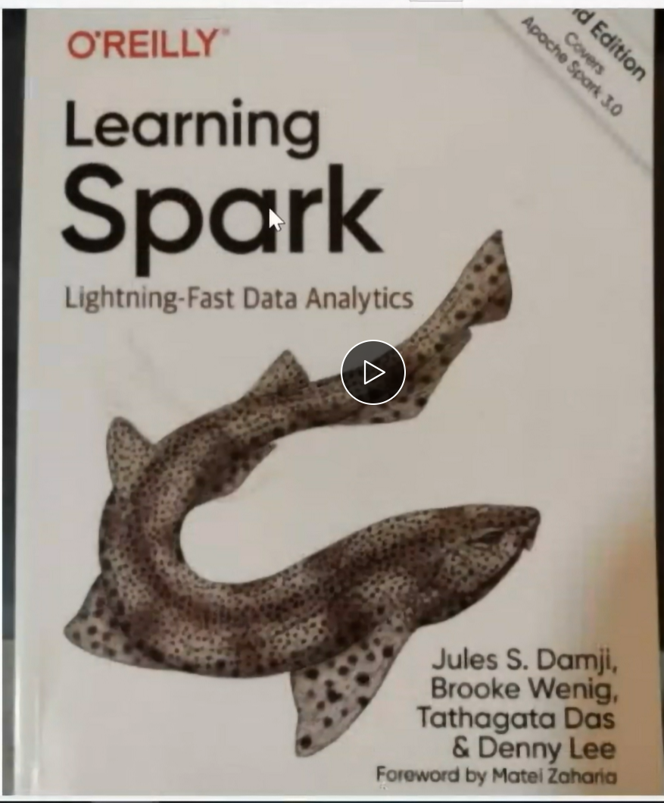

**So what are we going to learn?**

1. we are going to explain diff components of **spark applications** that we are going to **run on our local system**.

2. diff **spark deployment** methods

3. we are gonna discuss the imp of **spark session object** (itmd-510…diff b/w class and object? Object is an instance of class, class is a blueprint, you can have lots of objects from a class)

4. Concept of ‘**Lazy loading’**, the benefits of this is we call **spark actions and transformations.**

**Outcome:**

1. We will be able to explain diff components of spark application.

We will experiment with lazy loading and all the above 5 things.

**DO IT FOR LAB 1:**

All the source code of the textbook will be at this github repository if you click in the link below from slides (in bb, content - week 3 chapter 2 learning spark v2)

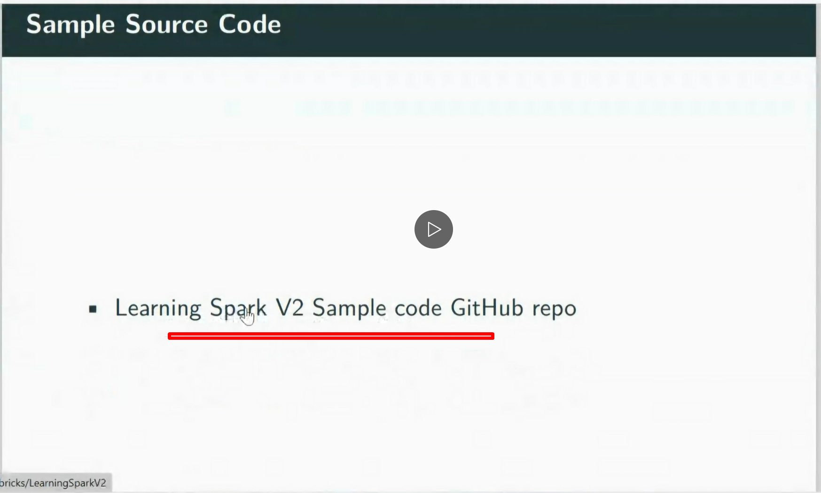 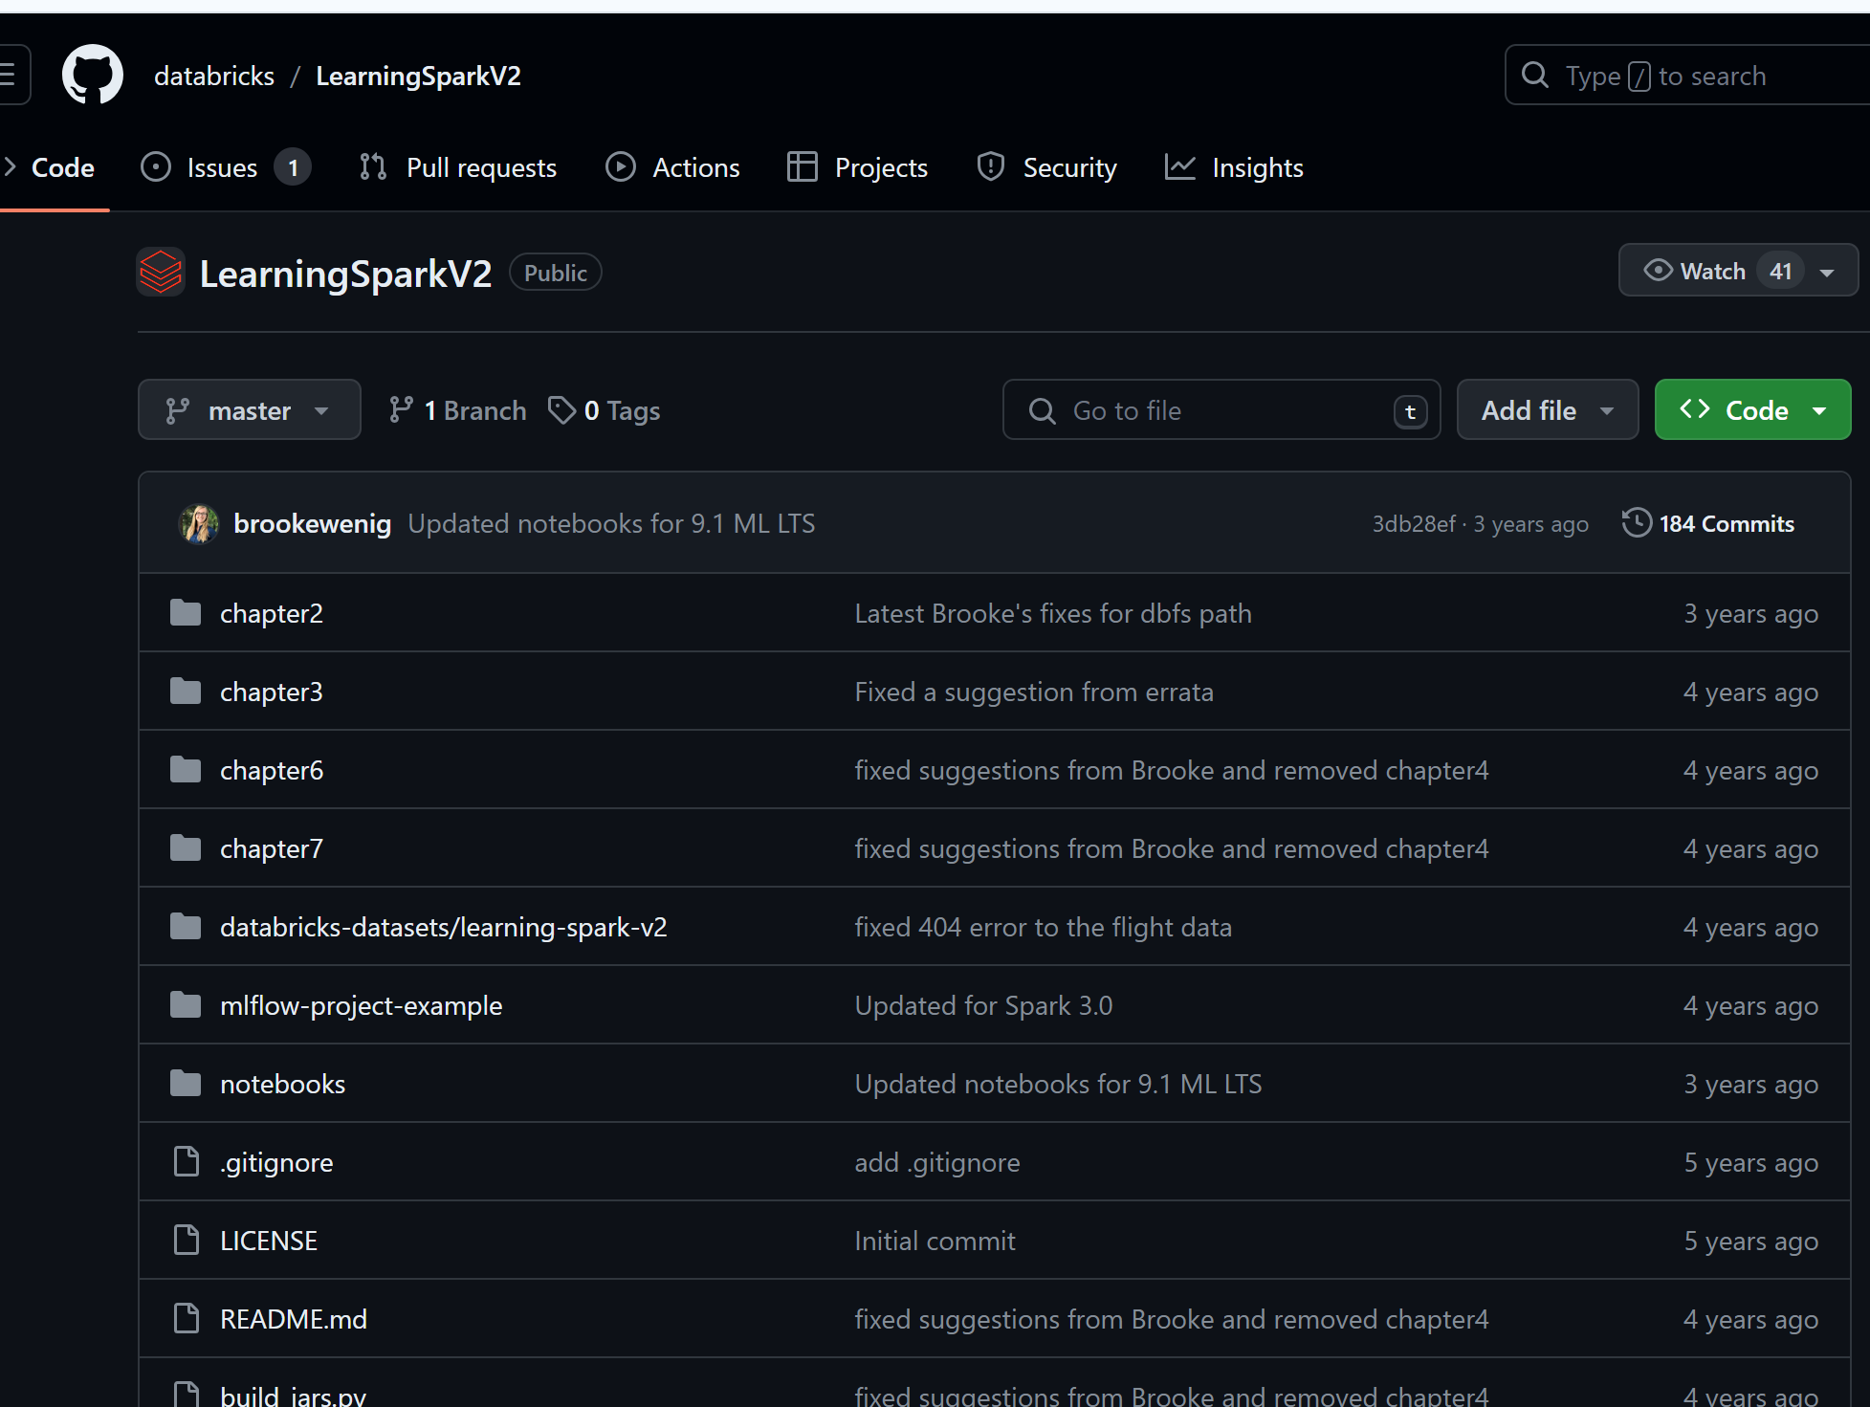

From the publisher code, Copy this https url and **CLONE** on your vagrant boxes (ubuntu anss-521 or almalinux) we will do in ubuntu jammy64 anss-521

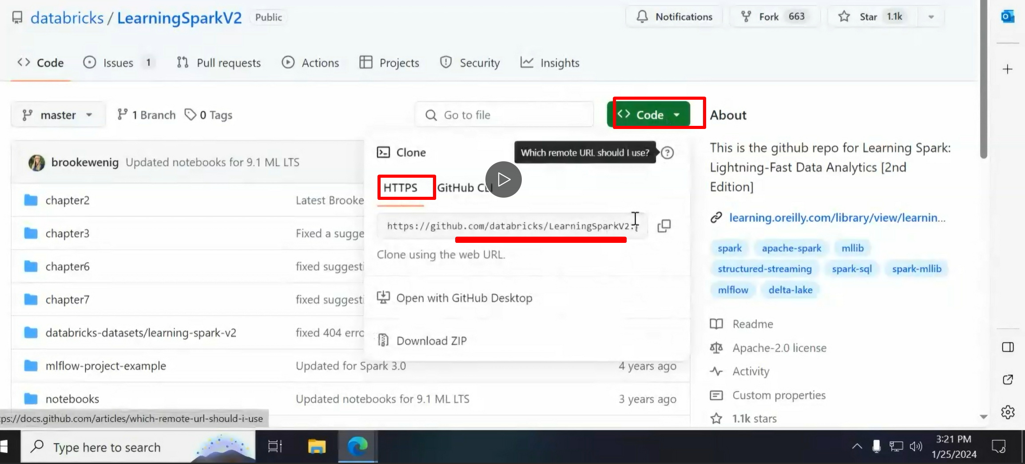

Becoz the the data sources we have are very small… so the data sources we need are in this repository.

We need that to do 1st assignment or lab1

**Note you **can also CLONE on your local system** as well*** on your windows or mac

**(but cloning this repo on vagrant box is must)**

**distribution execution of the spark cluster and spark application:**

**SPARK APPLICATION:**

In a certain sense **Spark application** is not any magical. **Its python , its java, and have our business logic inside of it.**

Its nothing special, its just we **can include extra libraries**, and **additional data types it can provide**,

There is secret sauce under the hood, that cluster does all the management and distribution on behalf of us(unlike the old way where we had to do all the allocation, management and re-assembly) now its done for us with spark application.

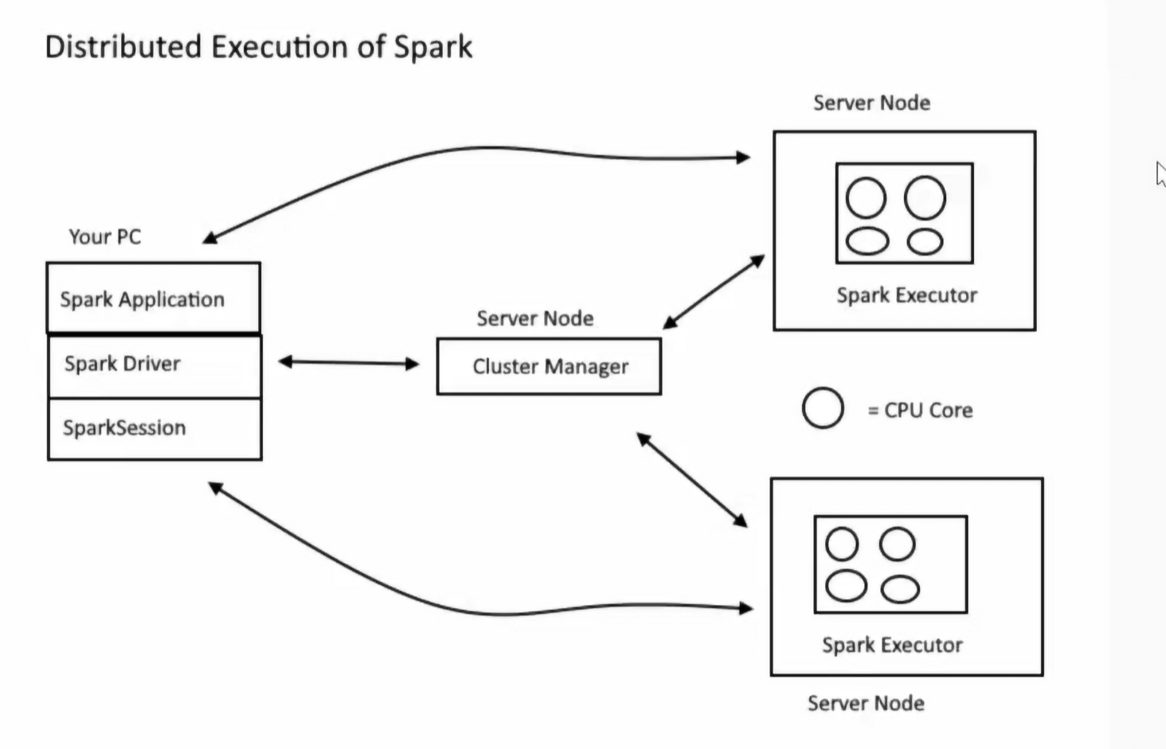 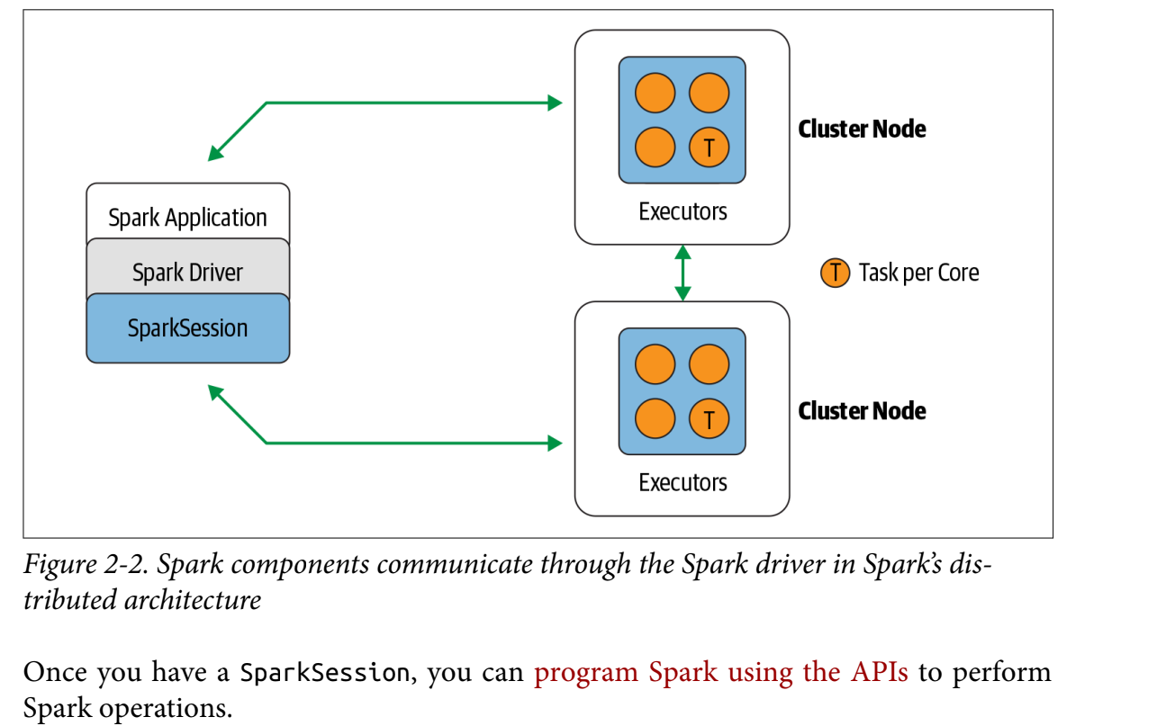

**Diagram explanation:**

we are **writing a spark application** (with python , scala, java) to do that we are gonna import couple of libraries and datatypes on the top and then you have the **spark driver program** which obviously runs the program, initiates, kicksoff req’s , **also driver program instantiates the spark session objects.**

**Spark session objects is where the magic happens.** If you are looking online for source code and not find spark session objects and find something else, you are looking at the old code, its not spark session it’s a single point where you interact with rest of the cluster through.

So you will **create** a spark session **object** and that **has functions and attributes** and then **we will execute** that and that session **object will be sent all over the cluster**. ~ where the cluster manager resides.

**CLUSTER MANAGER:**

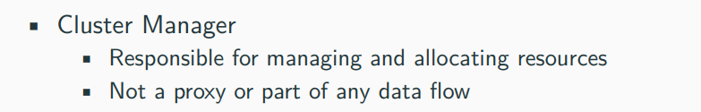

Once you execute your program, your spark driver will talk to the cluster manager.

But the data does not flow to the cluster manager.

Cluster manager job is to talk to all the server/cluster nodes “hey do you have any resources available? Nodes: yeah I have got this much available, and CM will come back to us and tell hey there is the space available and we will be getting ‘incoming object’ (SAY HELLO WHEN THEY COME 😊)

??? who : also constantly checks the process of a job, status, what task are you on, constantly reports you back, and then we will get **output on the screen**, like 20% done ,30% done like that , OOPS NODES FAILED,JOBS STRAT AGAIN issues etc.,

**SPARK DRIVER: SPARK DRIVER** coberts the SPARK APPLICATIONS in to SPARK JOBS and then DAGS

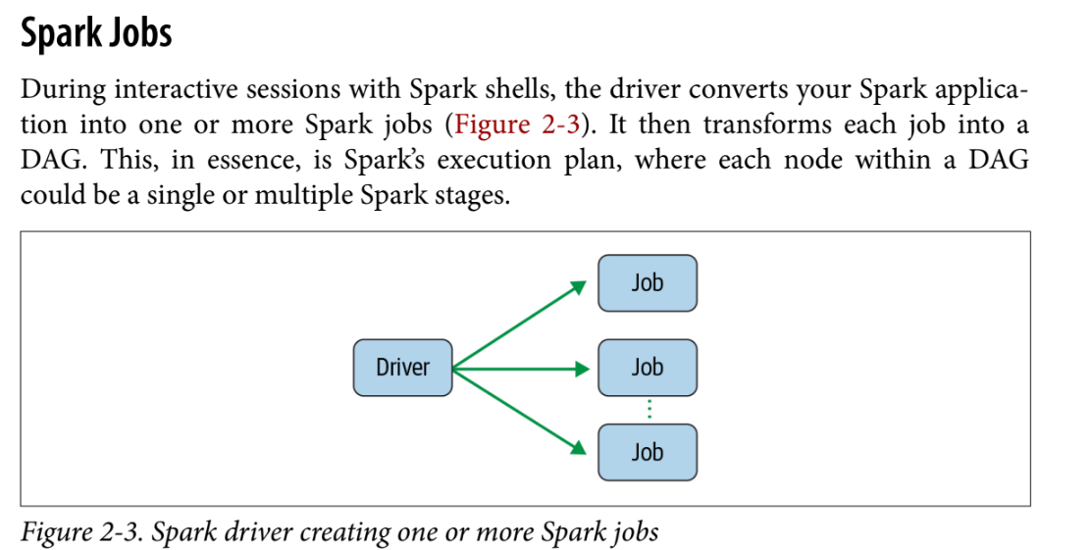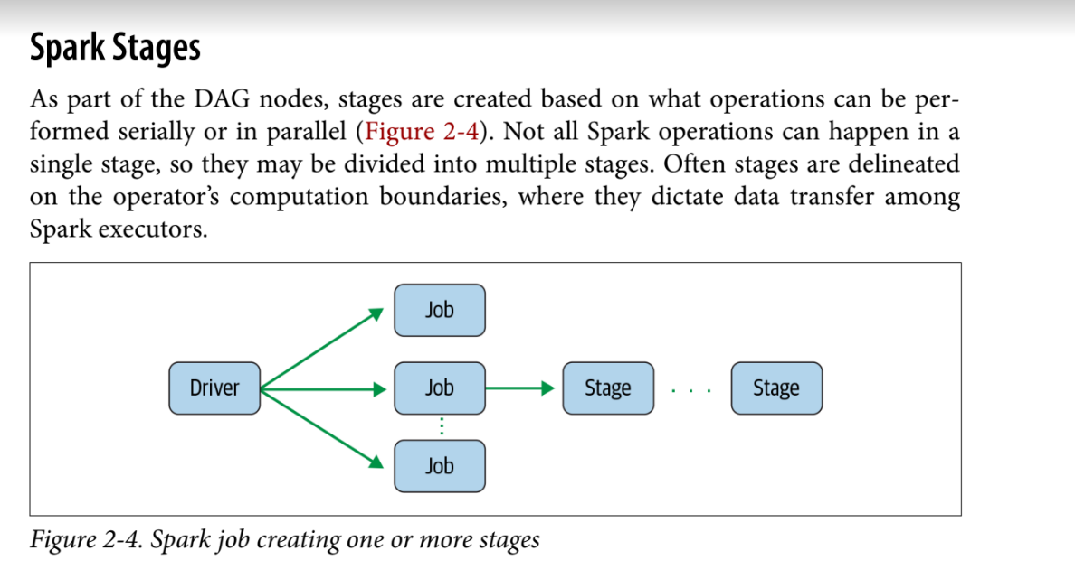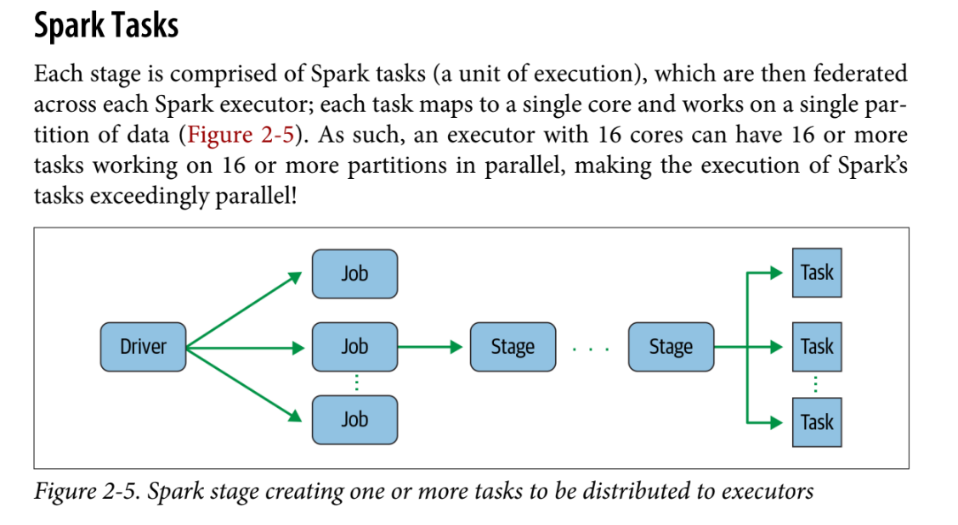

**SPARK EXECUTOR:**  
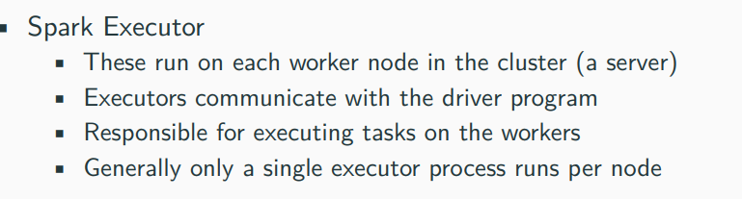

Also we can have many no.of nodes, you are processing in parallel, not only in 1 system, we have **spark executor** which kicks off the code in a lil **container**. It will get the data slice the data, to work on,take your code, allocate memory, ram, do the numbers. Return the results somewhere.

You can have multiple on 1 system or on multiple systems: running on parallel

Or if your dataset is bigger than 1 computer can contain like if you have 64 gigs of memory in your laptop, but you have 128 gigs of data. You can’t run that data dataset entirely on your system.

So the SPARK allows you to spread it across and it Works it in chunks and re-assembles it.

INJESTION ,TARNFORMATION , OUTPUT

**SPARK SESSION OBJECT:**

Its a **unified conduit for all the spark operations** and data.

In earlier we had spark shell object, spark sql object, spark java object,but all these are gone. Now only 1 ~ spark session object.

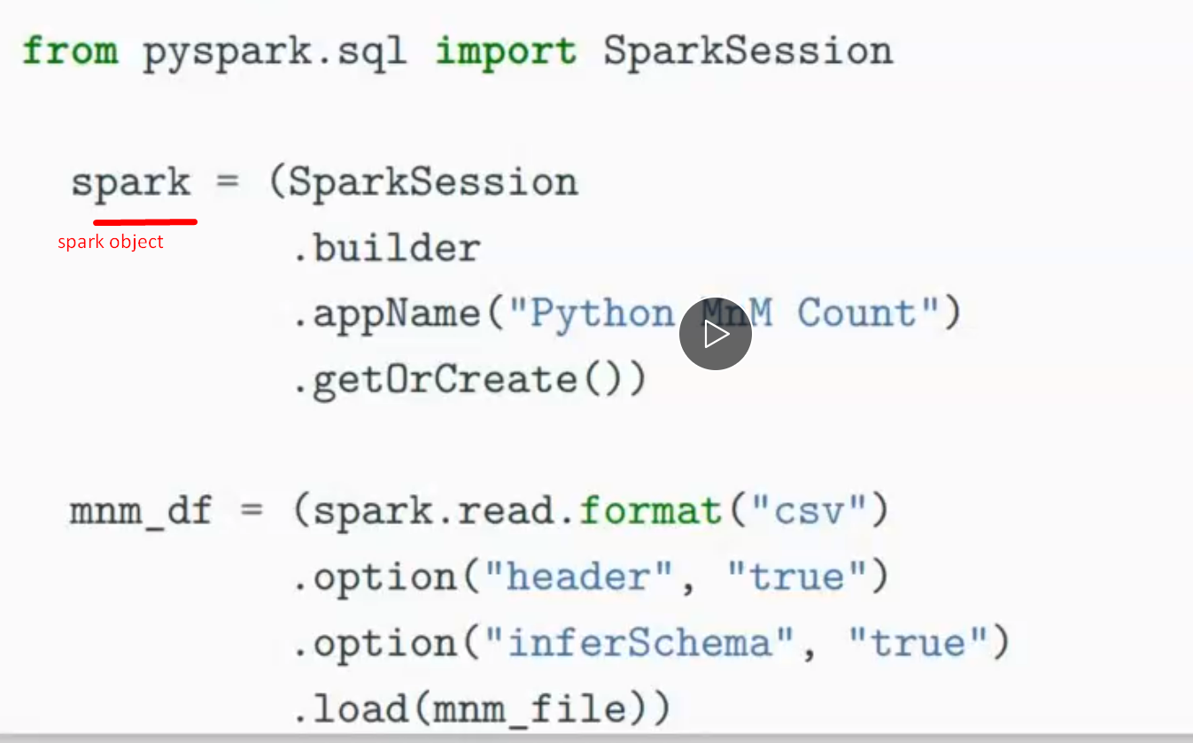 this is all the code that is required. (this is in python)

If you have spark installed or you are working on a system that has access to spark cluster like we do,,,we install spark cluster,

then it has spark object is called SPARK.

Does it has to be called spark? No

Is it a good idea to call the spark object as spark ? YES

That’s the convention given to us

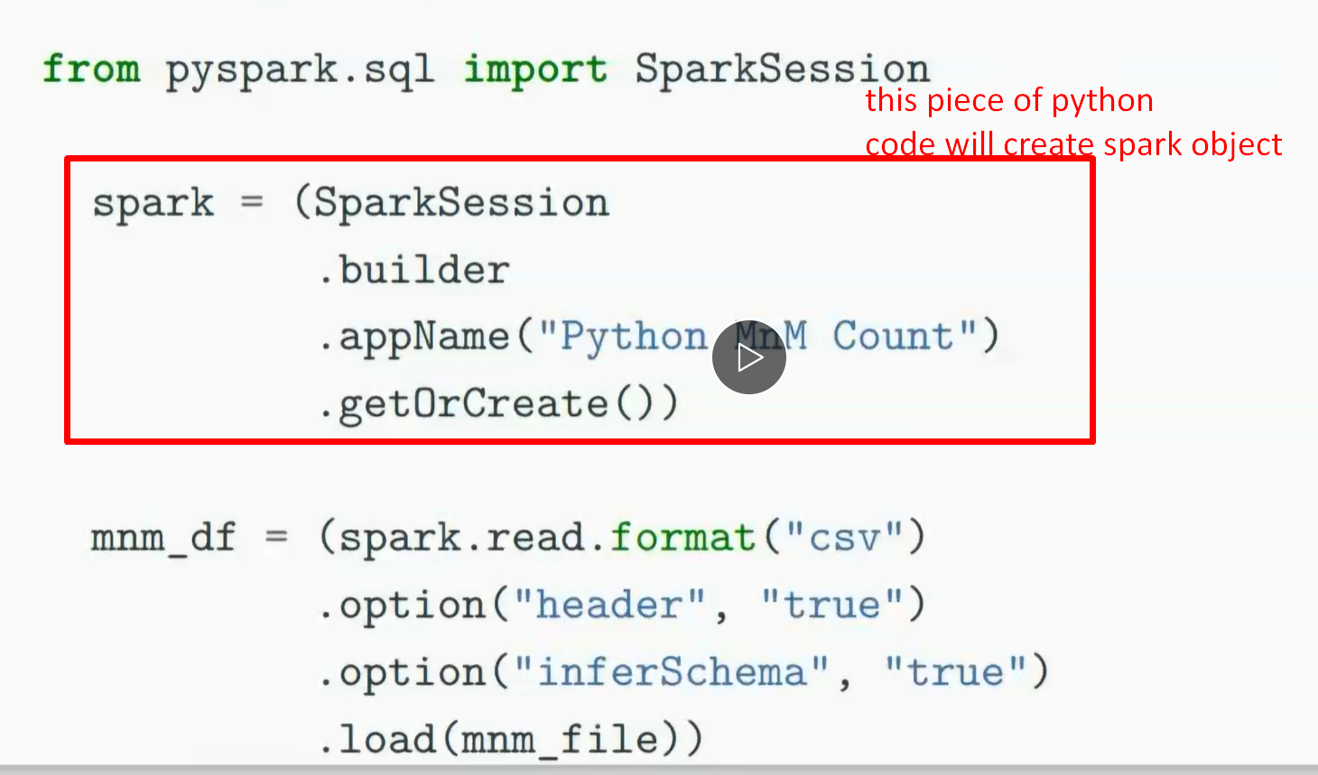 I have created a spark object ‘spark’

So now I have the spark object I can do al the actions that are part of the spark -class.

**Now the 2nd piece of code:**

We have a read command, we are declaring a data frame…in spark we only have 1data type ~ data frame (schema with no relations like excel)

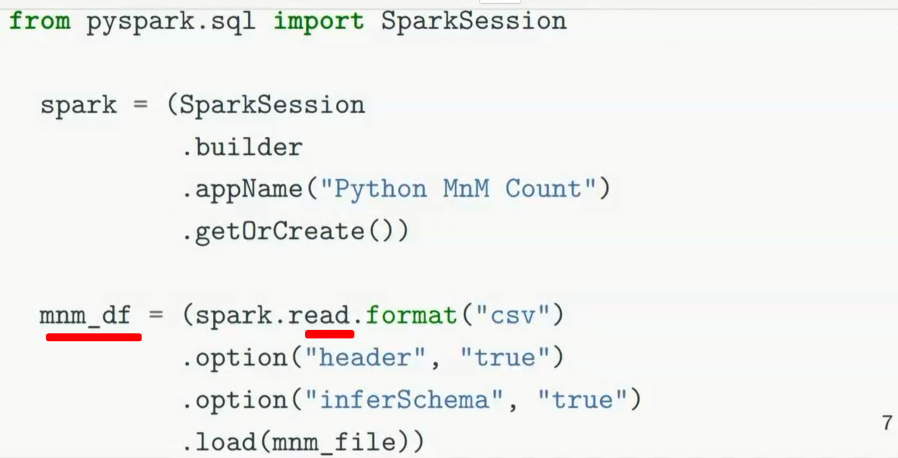

Spark had built in functions to read various formats. Here it is csv, it doesn’t have a schema, unfortunately df needs a schema

So there are couple of options for this:

**1. Header**: we are saying to give headers ( like the 1st column ):

2. **Infer schema** – if it starts with a letter its string, with number its int…but what if timestamp

3. **load**- loading that mnm file

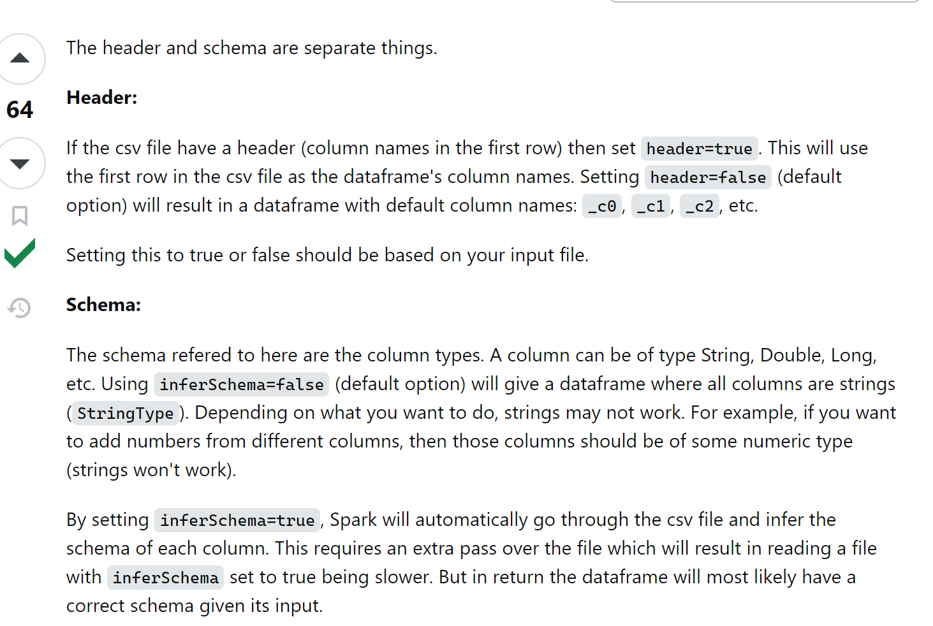

SO the above code will load the dataset in and takes care of distributing it across the cluster.

And after we just have our logic and do query : SELECT WHERE et., whatever the business logic is …we do that logic …query it,, retrieve the required data and submit it.

**DEPLOYMENT MODES:**

There are multiple deployment modes but we are running a **LOCAL CLUSTER .** even if you use diff language it runs in java by using jvm threads

A lil perform penalty for using python bcoz it needs to transcode it into java but the convenience of not having to learn to java and do it in python is worth the little.

PROF is gonna set up standalone spark cluster which has 10 nodes, and each node has its own executive jvm threads and is dedicated to all of that

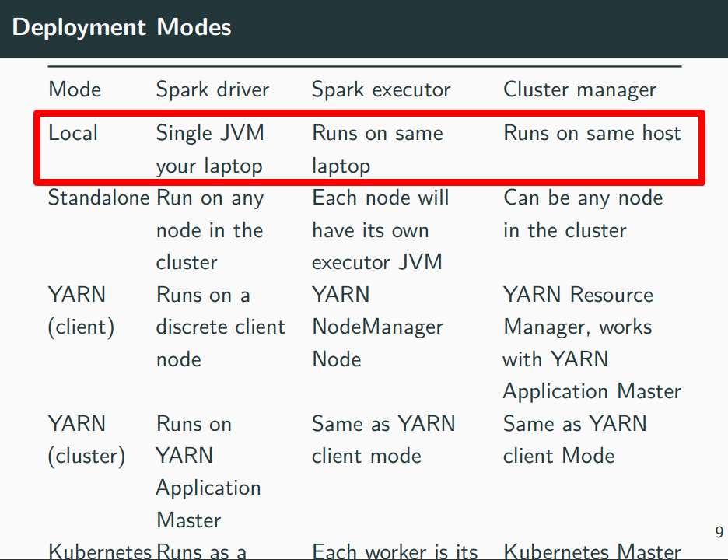

**DISTRIBUTED DATA STORAGE AND PARTITIONS**:

Physical Data **is stored** in **partitions** not like hard drive or something but **in HDFS or S3**.

Sparks treats all data as DF spark **puts it into** **memory(RAM)** but not in discs,

**it keeps in RAM why?** RAM is faster than discs + you can leave datasets and cache it in memory. For the next job you don’t need to create that data again, you can just re-use it or if you do ML, NLP you can iterate over a dataset without ‘loading ‘ and your data is spread across the cluster and stored in memory.

SO SPARK CLUSTERS WANT MEMORY TO STORE THE DATA. GIVE IT AS MUCH AS MEMORY > I THINK WE GIVE 500 gigs. We can do pretty good.

This partitioning idea allows us to efficient parallelism. Prof chopped the data sets up. Some executors on on node, some executors on another node. Each do a lil portion. I can run all in parallel

If 1 portion of job fails for some reason, that job will be re-assigned somewhere else. By cluster manager.

If a portion of job fails the rest will run. The entire job will not fail.

**PARTITIONS**: We can manually declare the no.of partitions or spark will divide for us. “HEY you got million records 10 nodes, ok each get a 100 thousand partitions.

**THERE ARE 5 SPARK application concepts:**

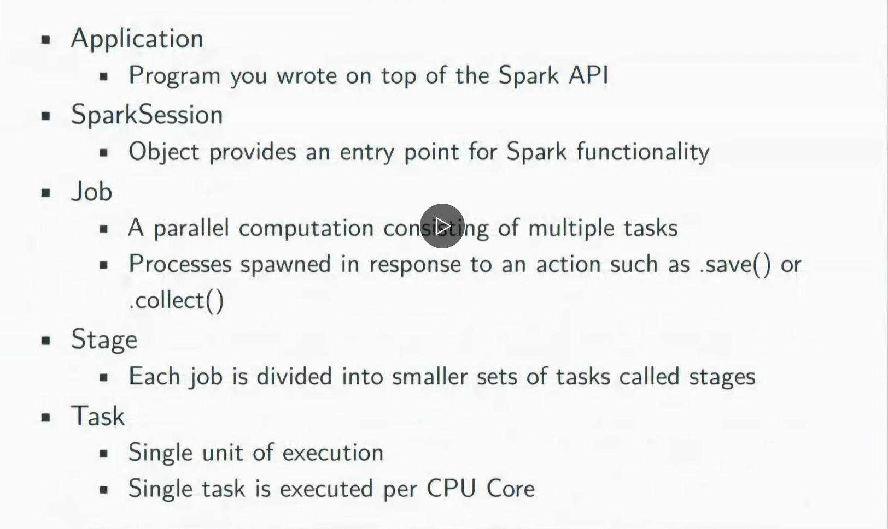





**Spark session : object provides functions like spark.read spark.show spark.list**

**TRANFORMATIONS ACTIONS LAZY EVALUATIONS:**

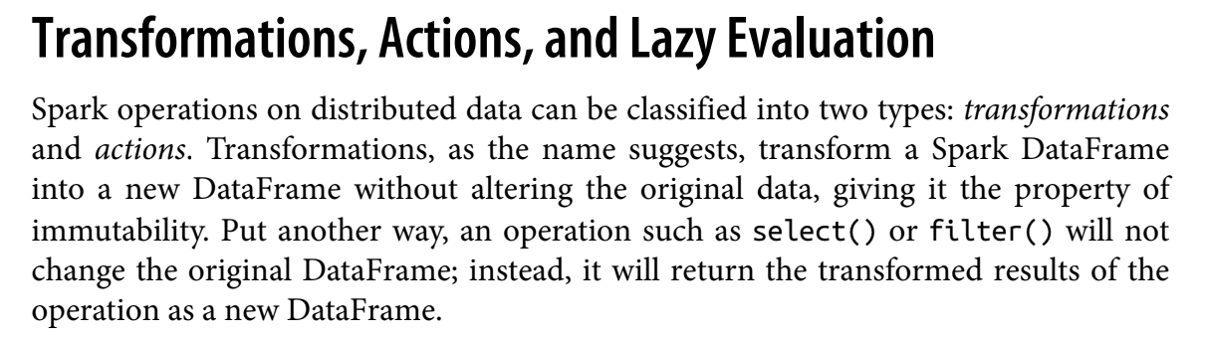

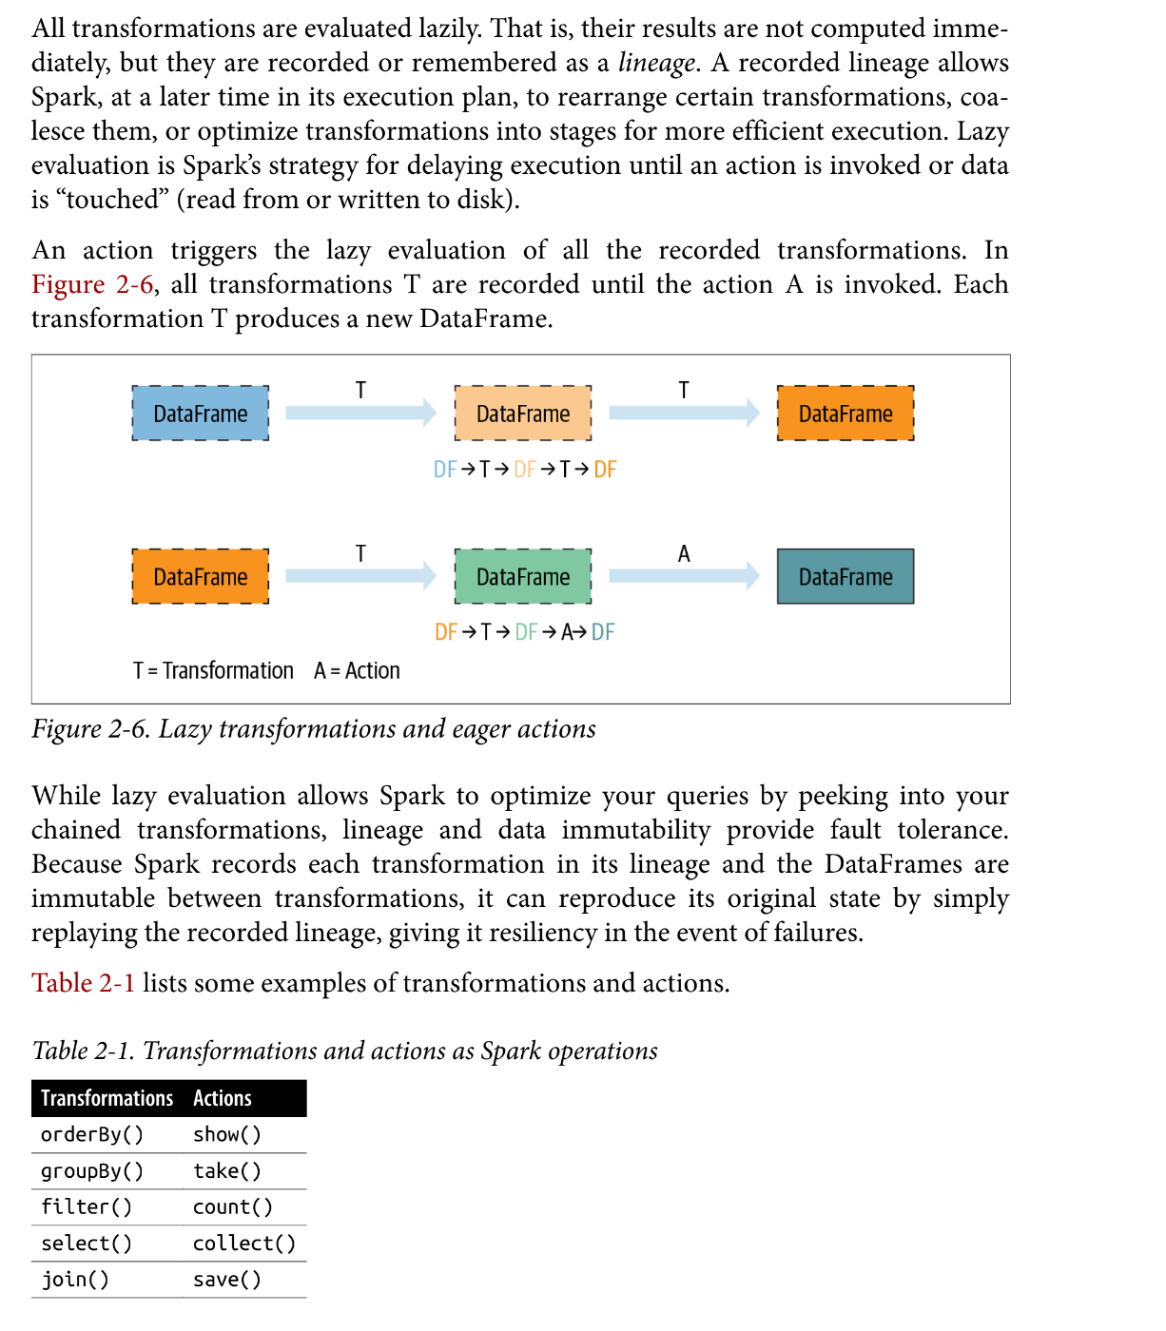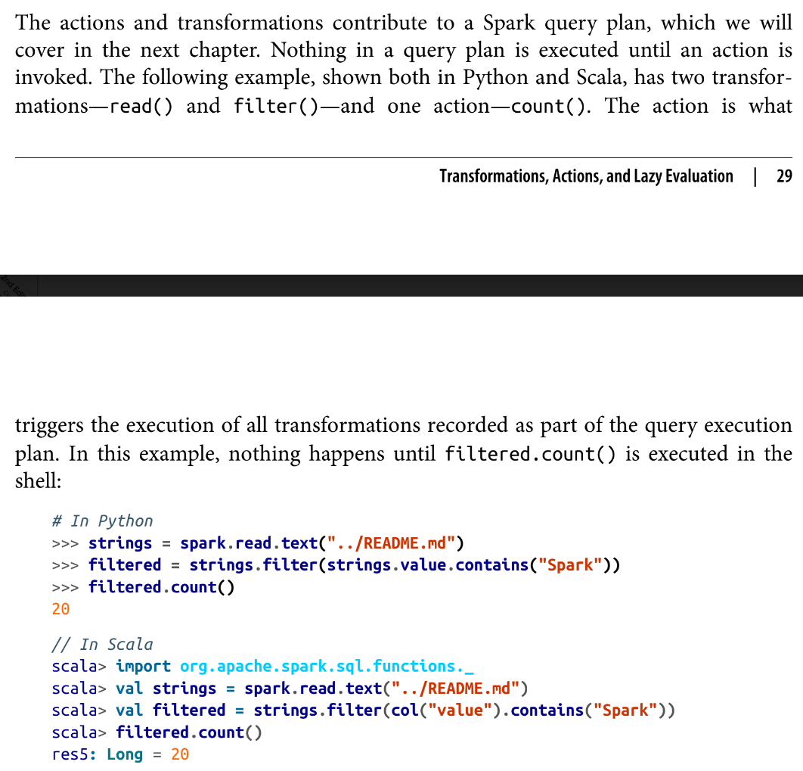

We have data in DF and you can do 2 things:

**1.tranform it** : these are functions/tranformations I learnt in ITMD523 adv topics on DB with yongzheng. **We are not getting new data we are re-arranging it**

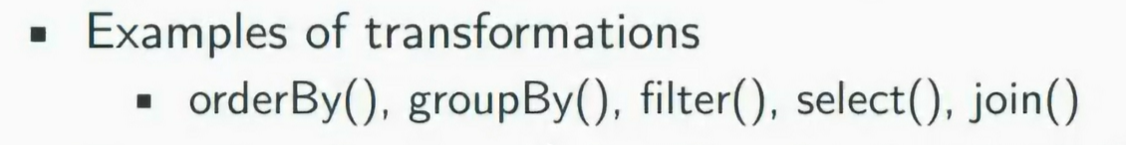

**2.take action on it: actions are get new data, display the data**

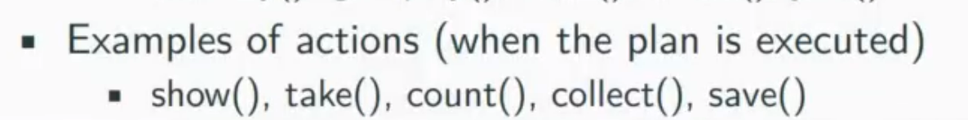

Dataframe.show : print the output to screen

Count: count the results

Collect: forces all our transformation’s to take place.it don’t do anything

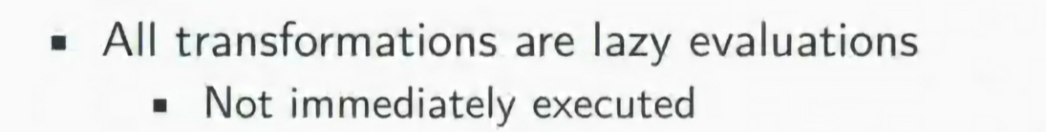

When you run a transformation unless a sql engine. Tranf does not take place right away. Sparkand will store up our trans and make a plan (like a shopping list) And not until you take an action to go and execute them. So it will plan it out also, it looks for in efficiencies and re-writes your plan.

**NOT UNTIL AN ACTION IS CALLED A TRANFORMATION TAKES PLACE**

**NOW THE ASSIGNMNET/ LAB: (other word doc) 26 min**

Spark has 2 things:

1. pyspark :

python interpreter, you can type commands ,it already loads the spark session objects. The quick if we want to test something out. You don’t have to complie the program, you just need to run it.

If we type pyspark we get that

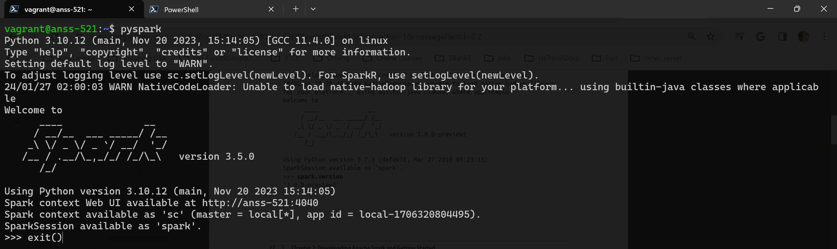

2. Sparkshell : If we type spark-shell we will open this ‘scala’ is one of the native language spark supports. (java+python)

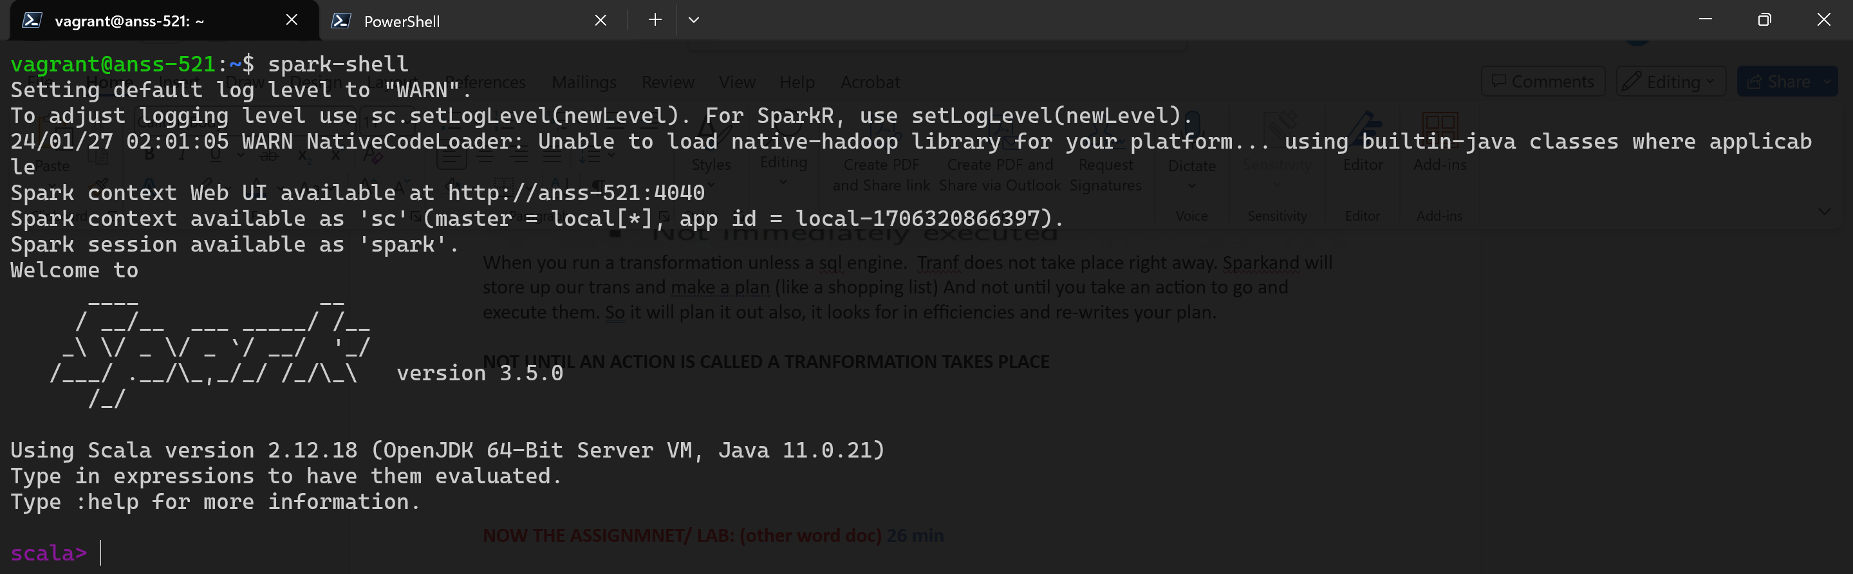

**STEP1: CLONE THE SURCE CODE REPO**

He cloned the source code repo::

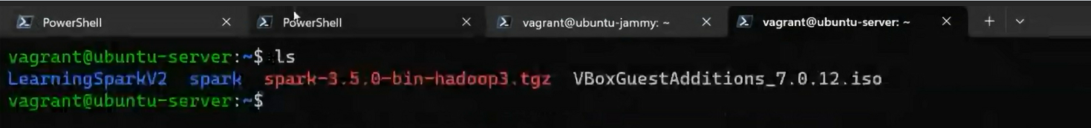

we can use this command: **https://github.com/databricks/LearningSparkV2.git**



All the source code of the textbook will be at this github repository if you click in the link below from slides (in bb, content - week 3 chapter 2 learning spark v2)

 

From the publisher code, Copy this https url and **CLONE** on your vagrant boxes (ubuntu anss-521 or almalinux) we will do in ubuntu jammy64 anss-521



Becoz the the data sources we have are very small… so the data sources we need are in this repository.

We need that to do 1st assignment or lab1

**Note you **can also CLONE on your local system** as well*** on your windows or mac

**(but cloning this repo on vagrant box is must)**

**Go to sparkshell:**

Do some exercises:

**val strings = spark.read.text("../README.md") ~(textbook page 24)**

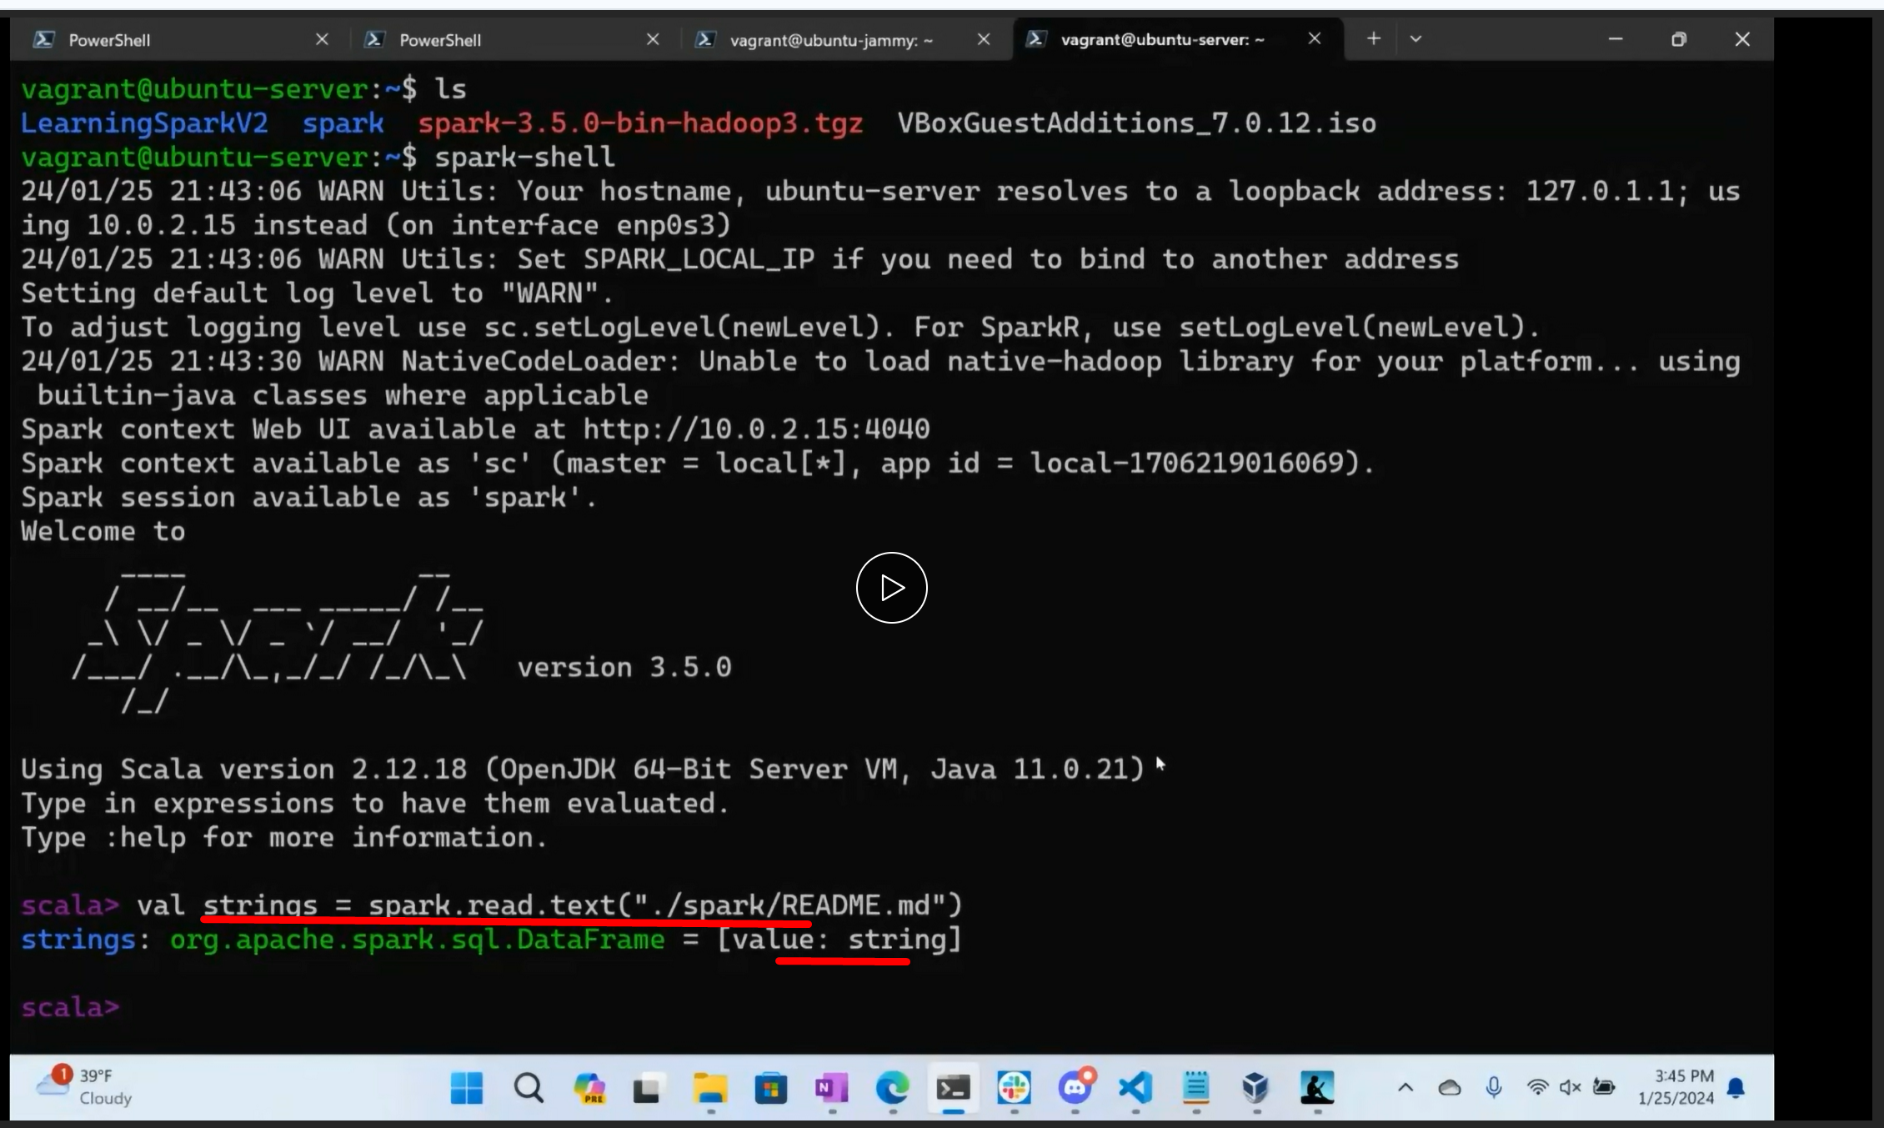

Transformation and action :

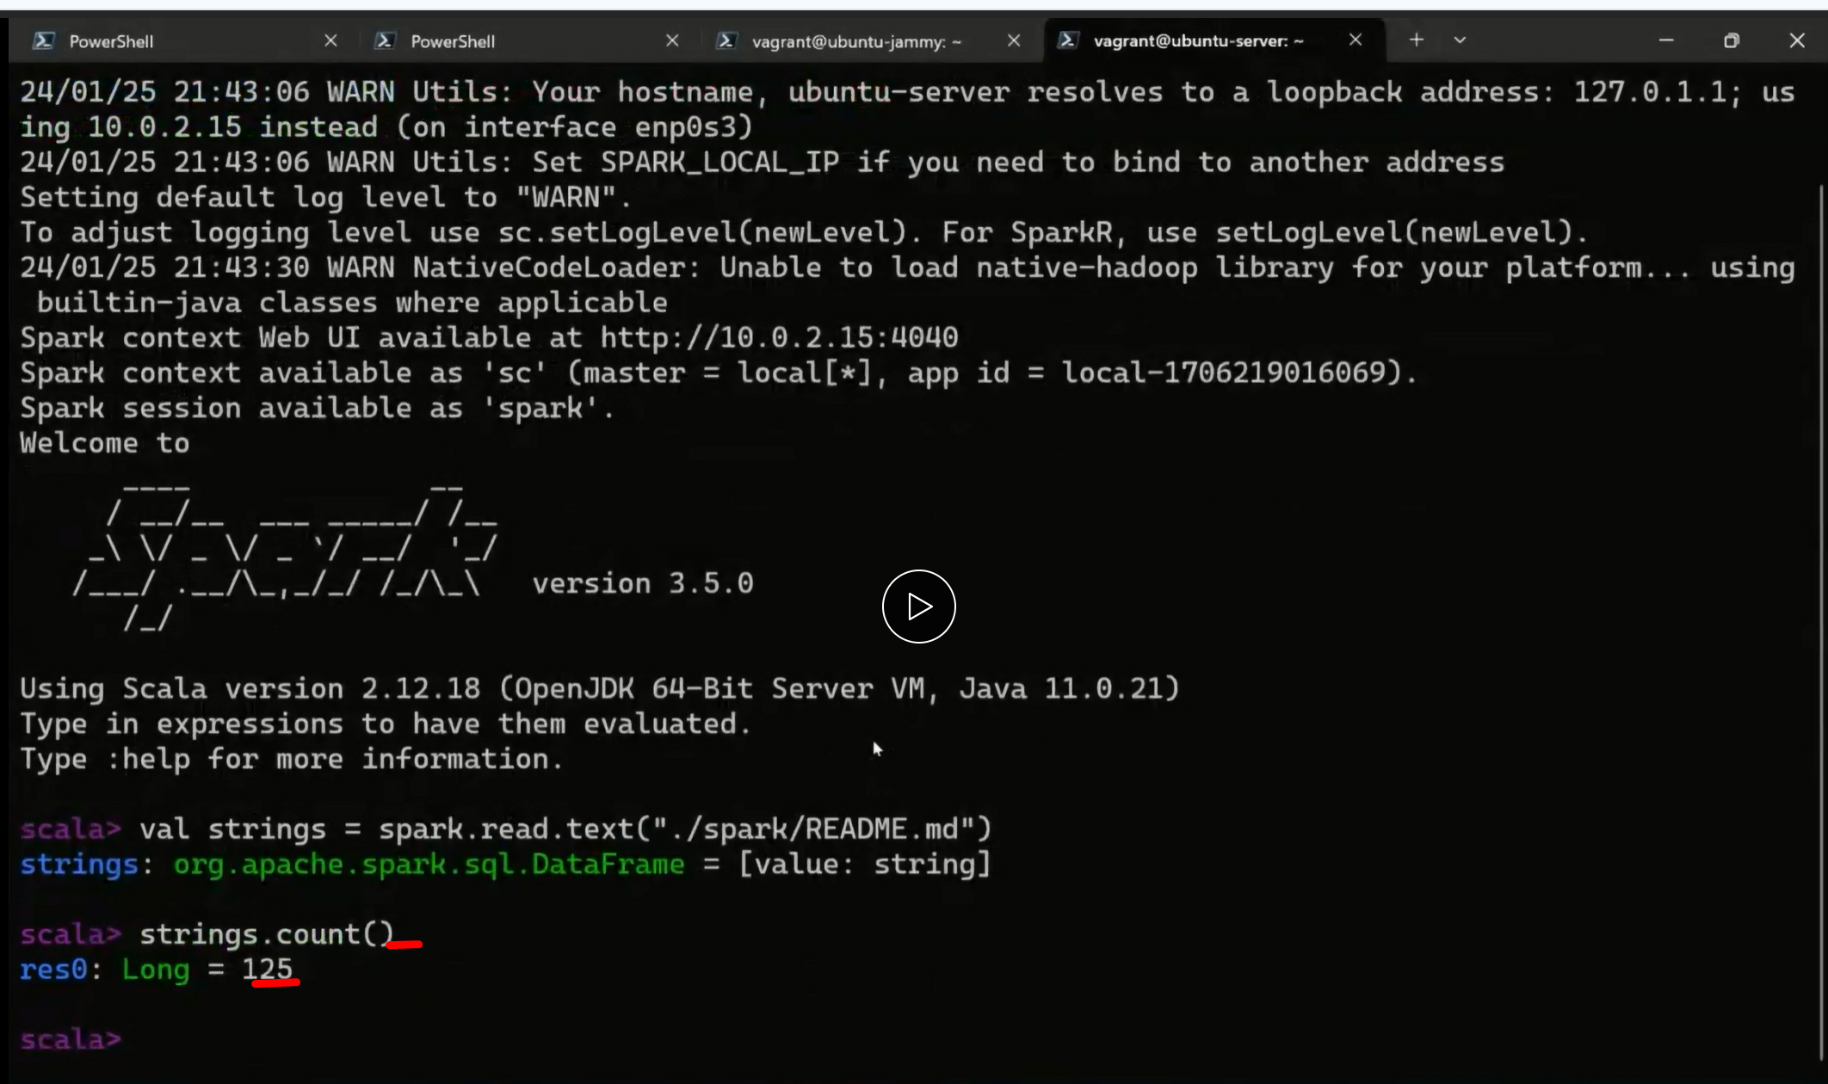

To Quit ------ quit or cntrlD

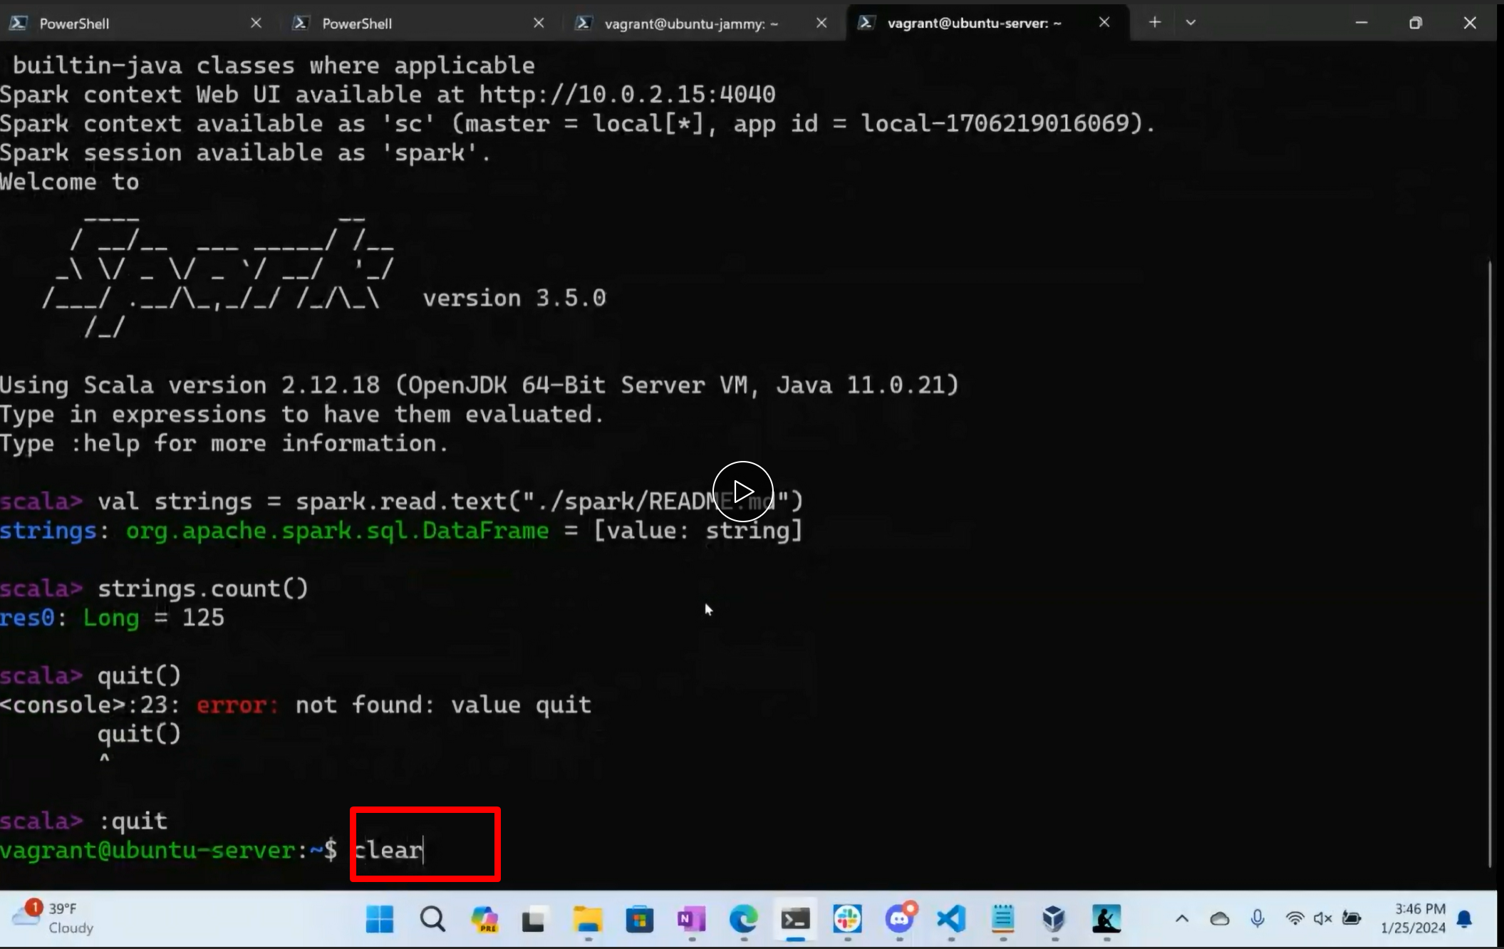

If its in pyspark …similar but no ‘val’ declerations

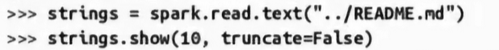

We can do these just for exercise.

It doesn’t matter what text file , but if we have spark install we have README.md in spark directory

**OUR HOMEWORK IS STAND ALONE APPLICATION (page 34) (video 32min)**

**STEP 1: Clone the source code repo into vagrantbox:**

**We are gonna do counting mnm’s for cookie**

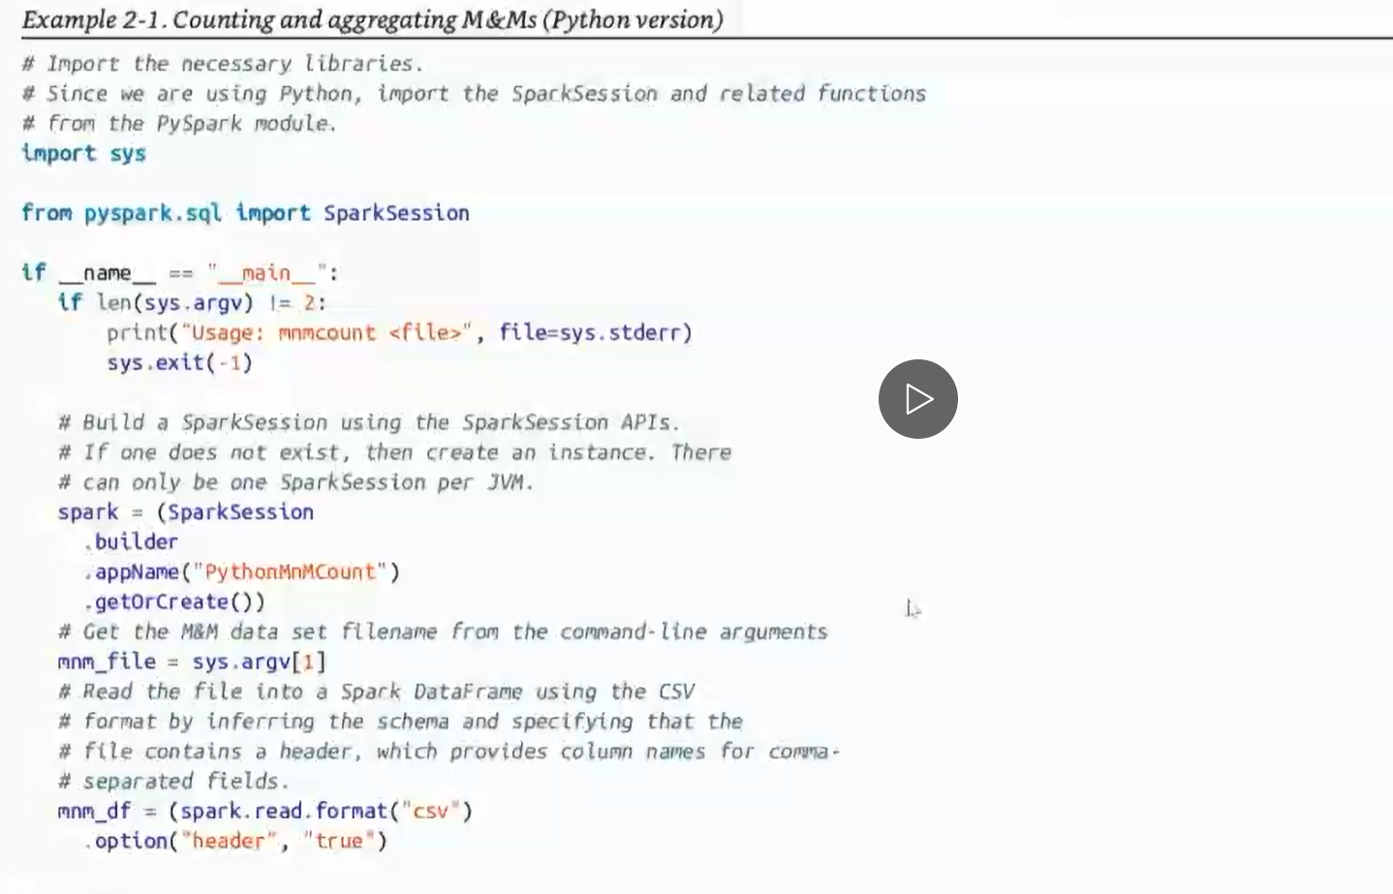

This source code is available at source code **, but don’t copy paste it….type it up in vscode (prof need to see commits)**

So when we load, we do **select** statements, we got a data frame and we query it out

Df’s are immutable, so you don’t overwrite them, you declare a new one…you write data to new one.

**THERE IS MESS IN this FOR US:**there is a field in this database called count and there is a function called count which counts count

If count is in quotes, it’s a column.

There is **show function** ~ be careful with that if we have million records we need to be careful with n value…. here n = 10

**Here is prof’s**

**We can do this cd only if we clone that repo in our vagrant box.**

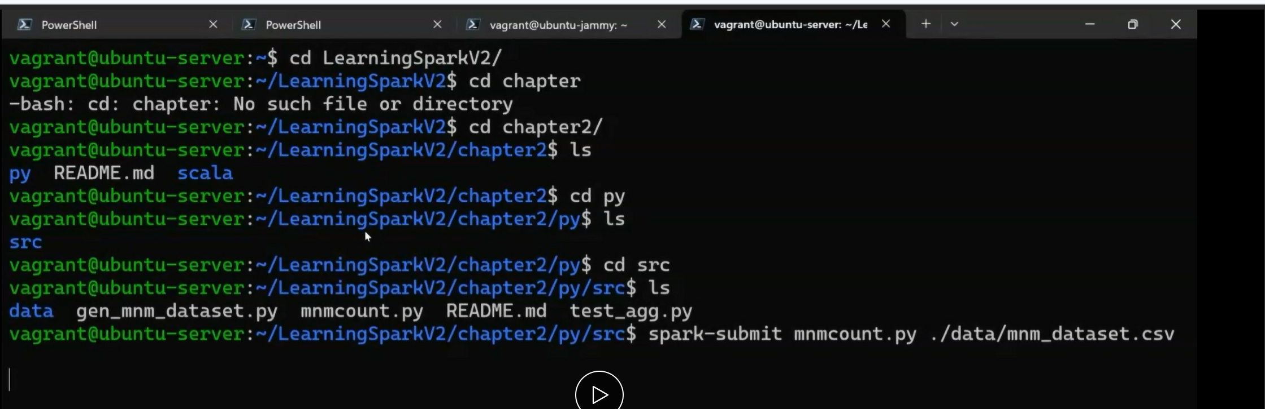

**He did spark submit from py directory**

When he do **spark submit** We will see a de bugging output spinning up

The logic we did in vs code (with the source code) is printing out in the screen

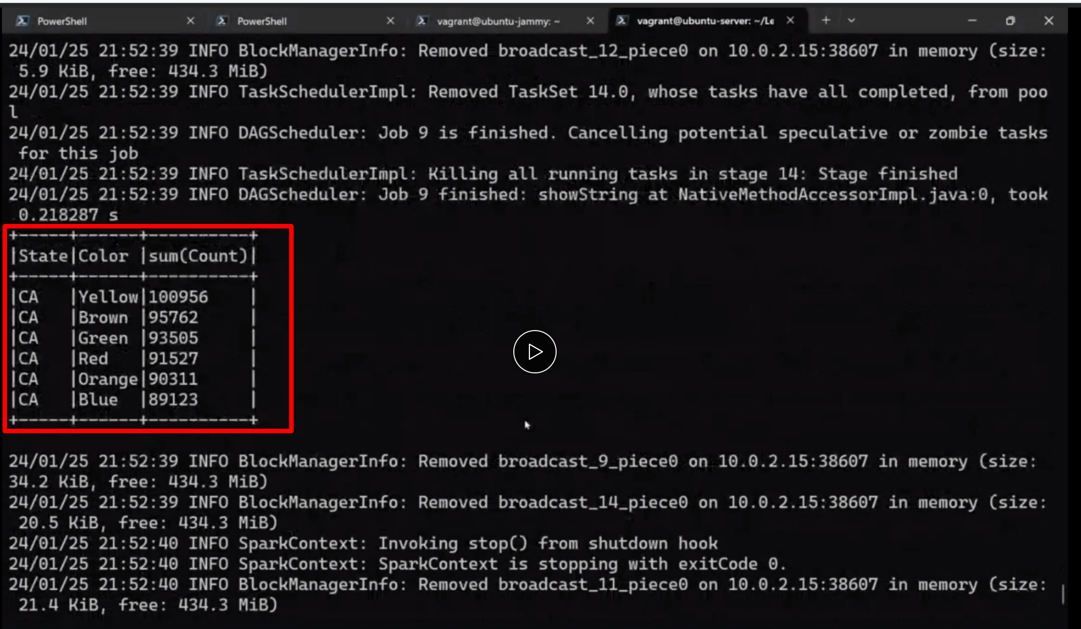

**He wants this screenshot and the source code**

**Where is the source code going be ?**

**It’s going to be In our local system**

**But in vagrant box: do this (DON’T COPY PASTE THE CODE)**



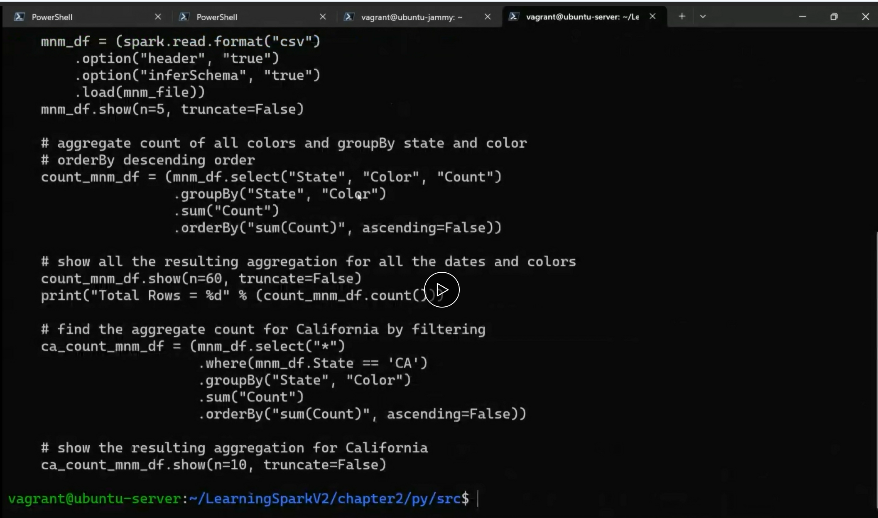

**He is copying it just to show us:**

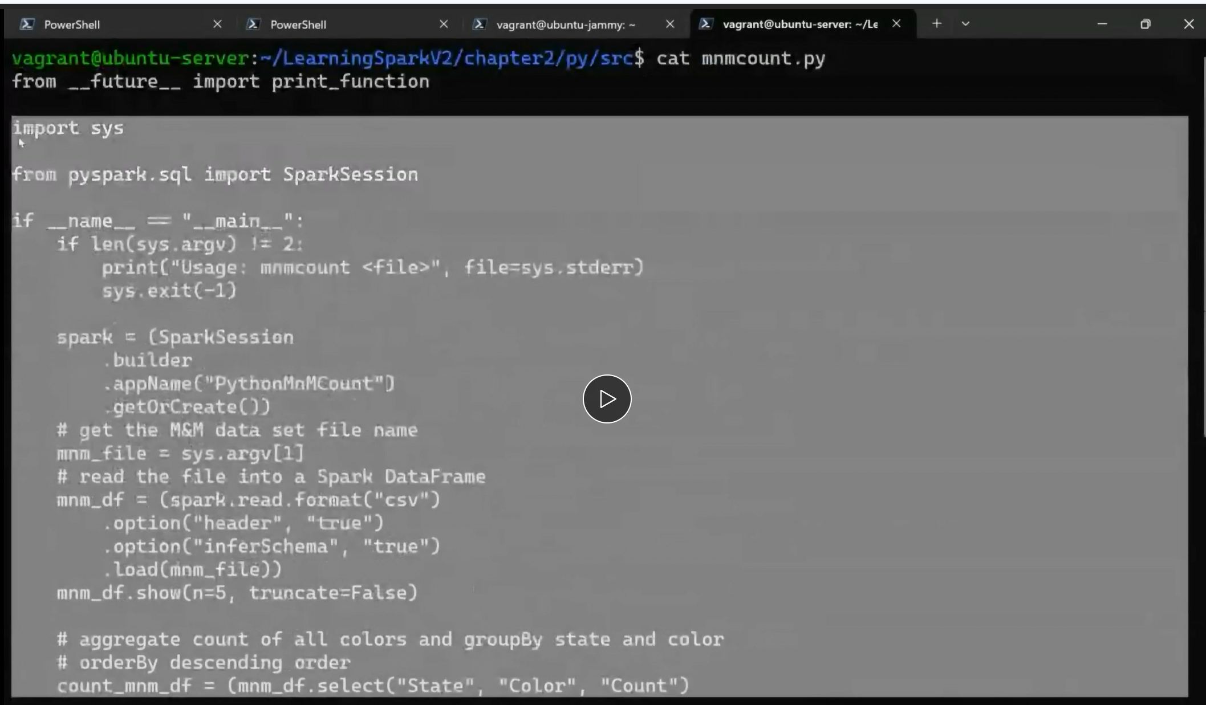

**On your local system…(VSCODE)**

**Go to our repo(nannadevara)**

**Under itmd-521 create a folder labs and under labs week-03 and under week-03 make a new file (.pyfile)**

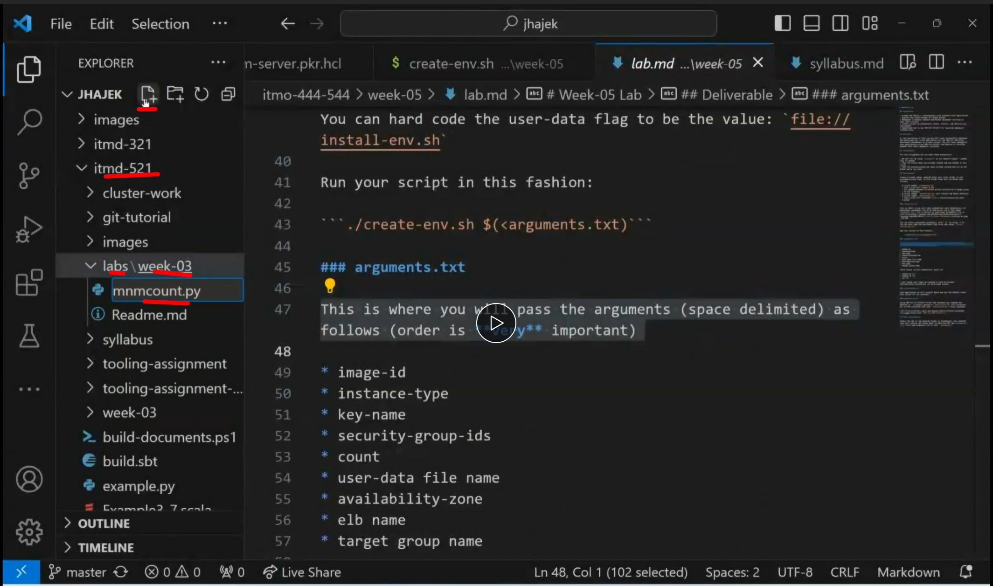

He pasted the source code here.

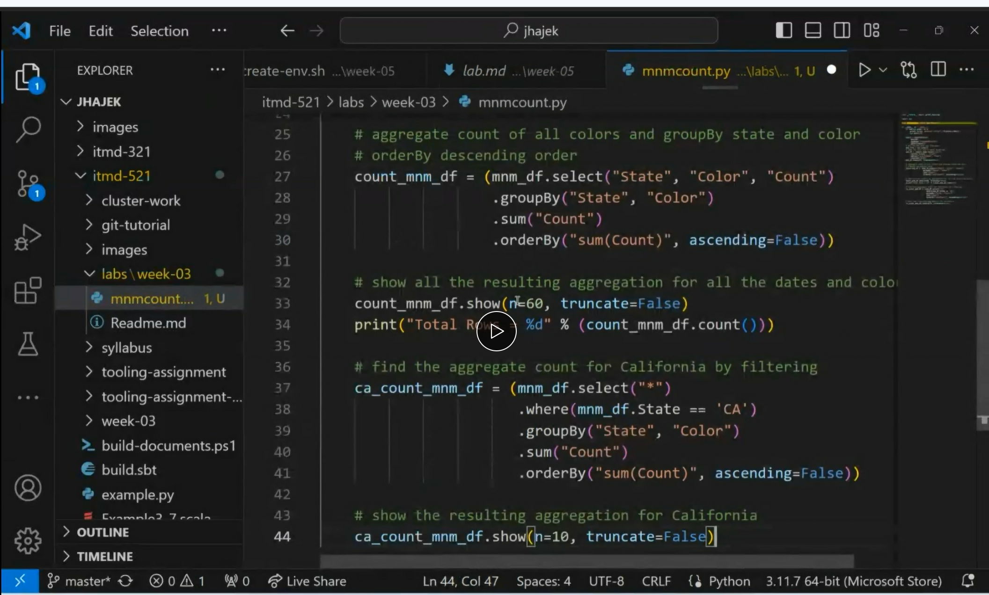

**For us we need to write step by step code and do the commits.**

**Each function you add ..commit**

**Label the commits like: Add function for count , select etc., like that**

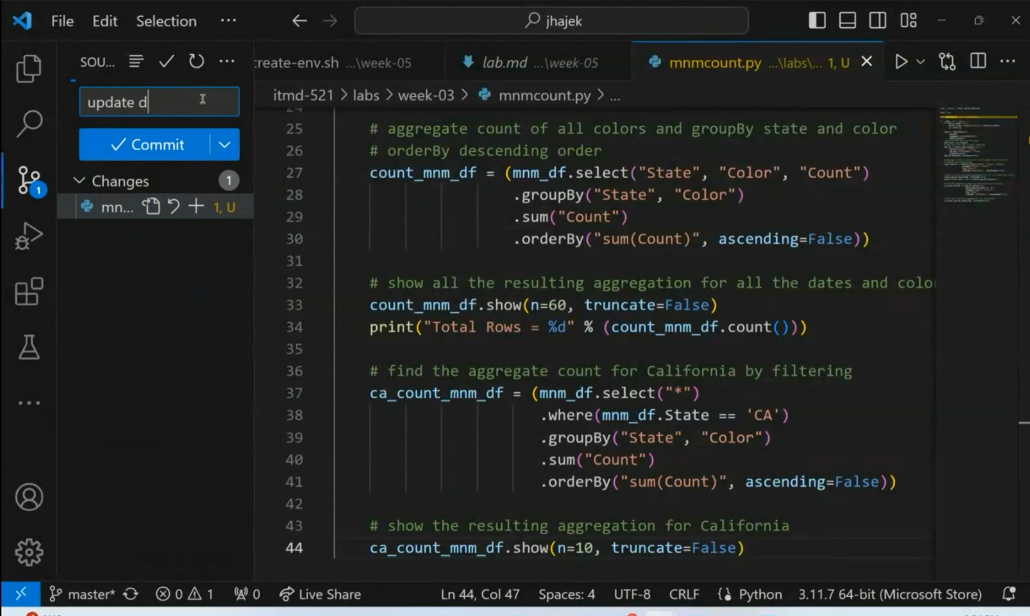

**Go to vagrant box and do this.**



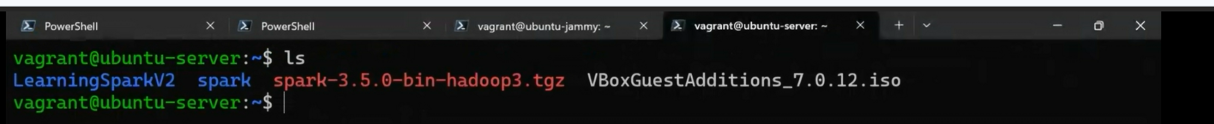

**Again he is cloning his repo(not the source code)**

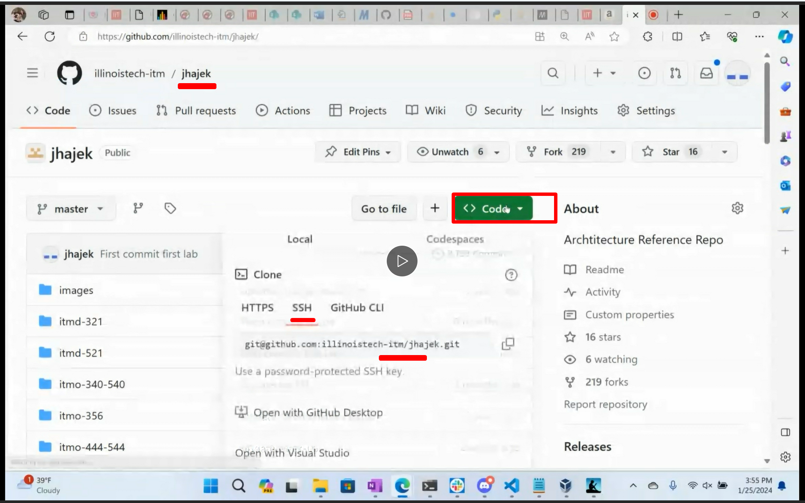

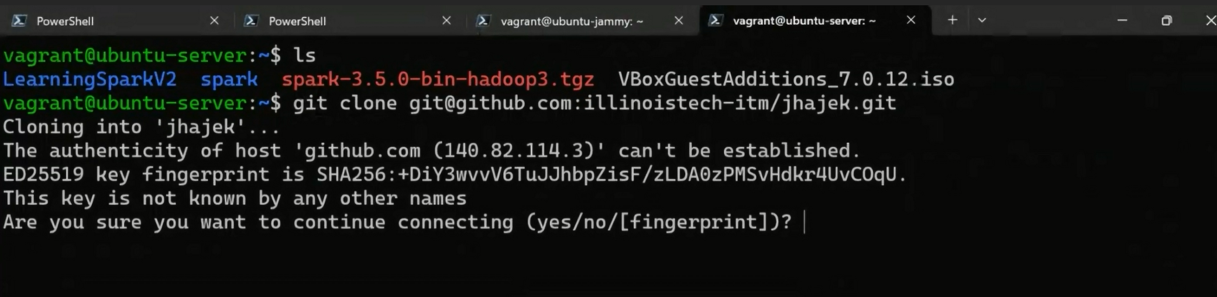

**He was not able to clone with ssh, so he is cloning with https again**

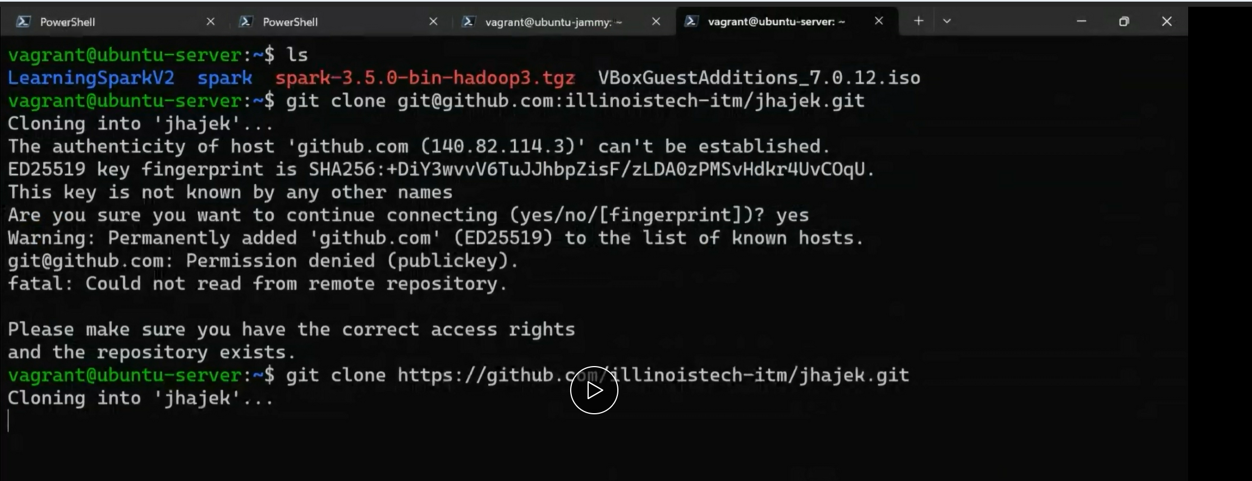

**After cloning done.. cd into itmd521 week3 and run that code**

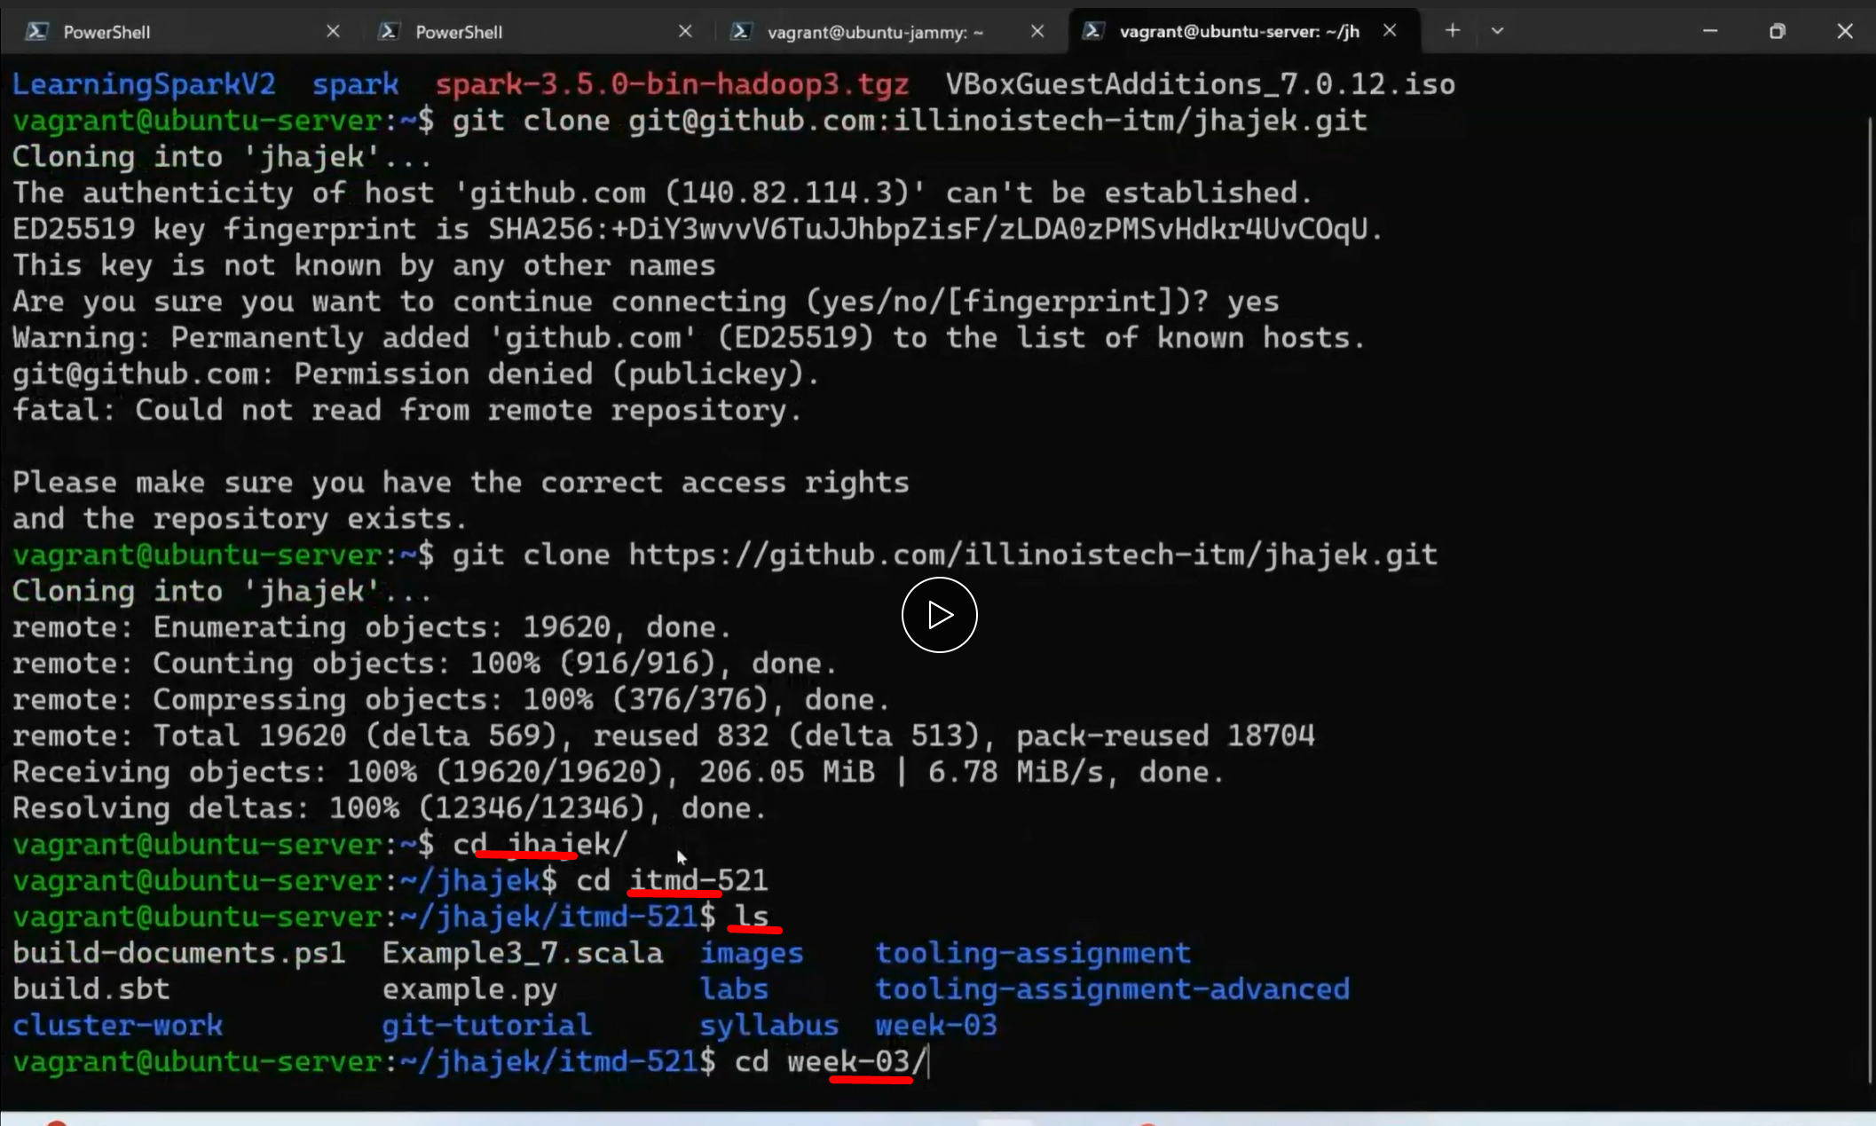

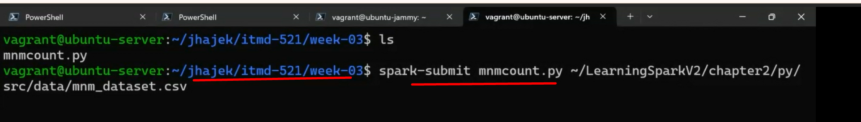

**We will get an output here with our initials, earlier spark submit was from other directory (lerningsparksession) but we need to do spark submit from out repo week-03 directory**

**We also need to with scala also….earlier code is python…this is the scala src code**

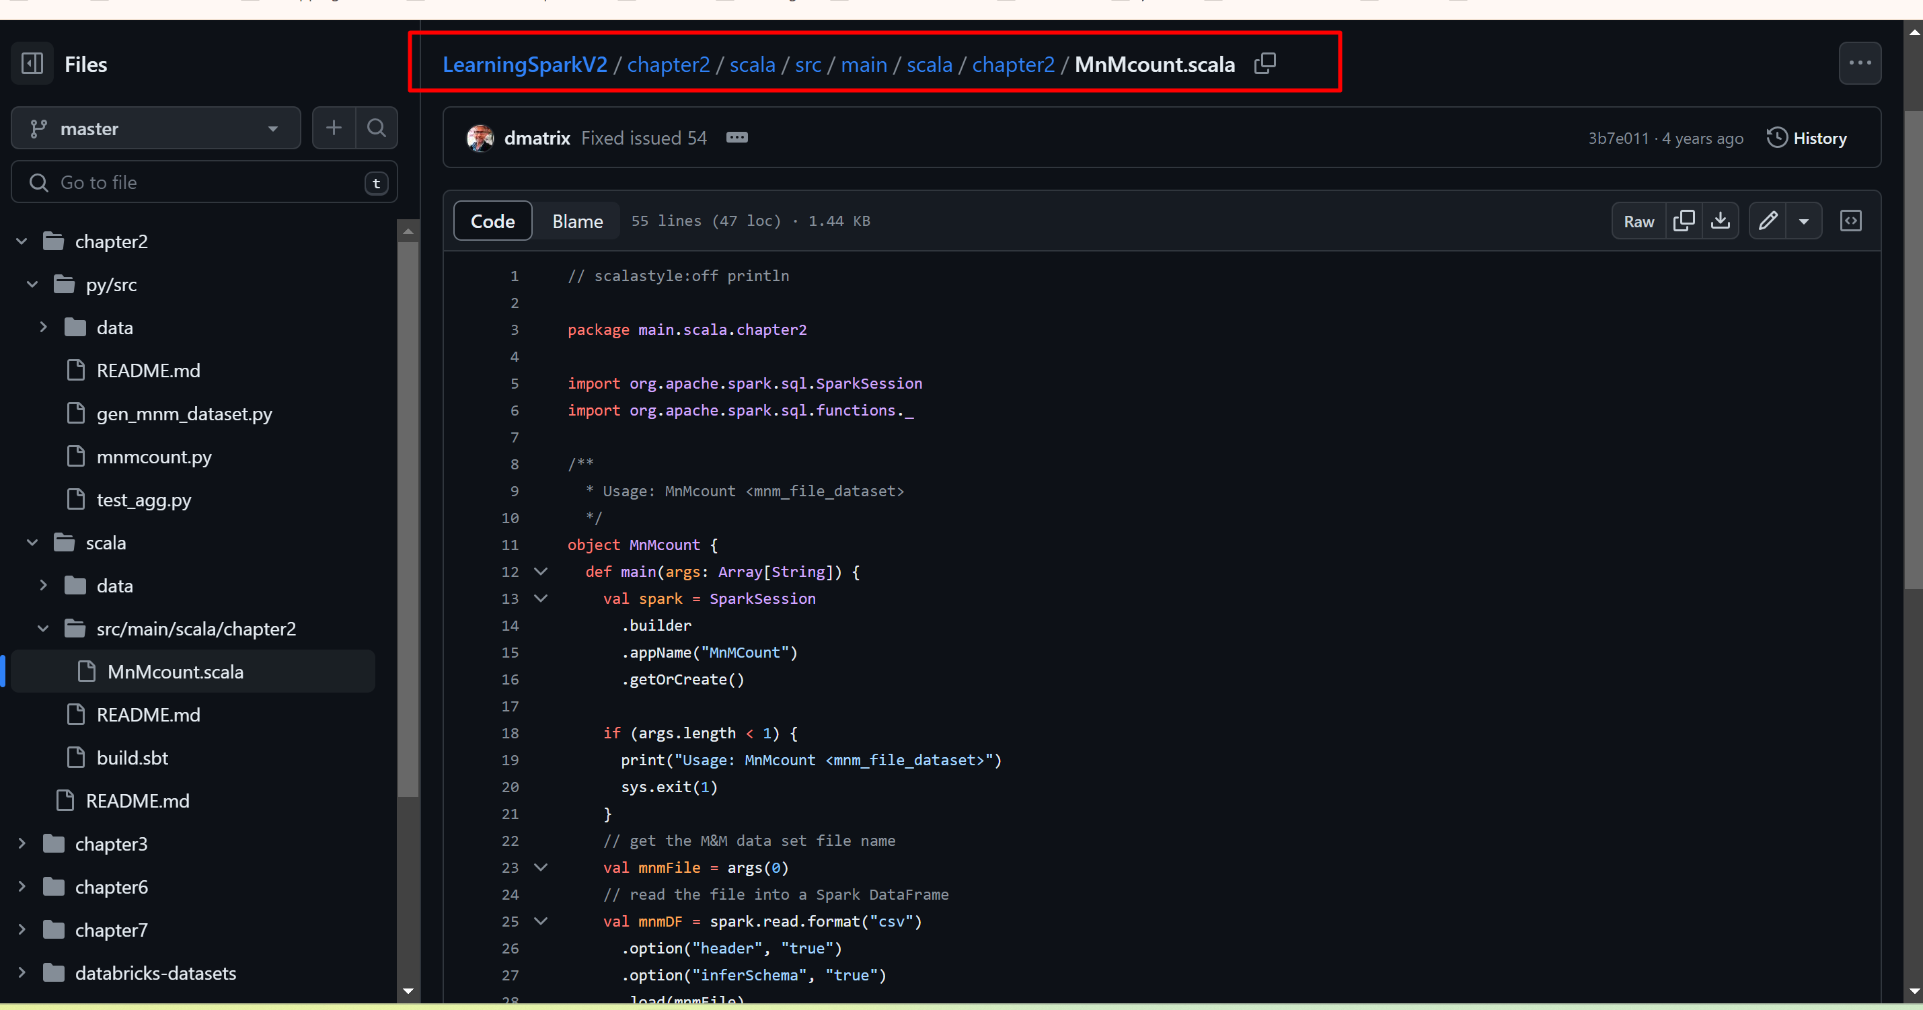

**To do with scala…we need sbt build file that uses maven**

**To build sbt we need to go to scala directory (page 41-textbook)**

